CSA0430--OPERATING SYSTEM LAB PROGRAMS

Experiment 1-
Aim: To Create a new process by invoking the appropriate system call. Get the process identifier of the currently running process and its respective parent using system calls and display the same using a C program.
Program:
#include<stdio.h>
#include<unistd.h>
int main()
{
printf("Process ID: %d\n", getpid() );
printf("Parent Process ID: %d\n", getpid() );
return 0;
}
Output:
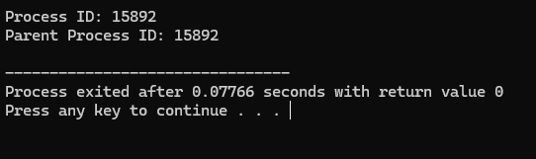
Result:
The code is successfully implemented using c program.

Eperiment-2
Aim:
To Identify the system calls to copy the content of one file to another and illustrate the same using a C program.
Program:
#include <stdio.h>
#include <stdlib.h>
int main()
{
FILE *fptr1, *fptr2;
char filename[100], c;
printf("Enter the filename to open for reading \n");
scanf("%s", filename);
fptr1 = fopen(filename, "r");
if (fptr1 == NULL)
{
printf("Cannot open file %s \n", filename);
exit(0);
}
printf("Enter the filename to open for writing \n");
scanf("%s", filename);
fptr2 = fopen(filename, "w");
if (fptr2 == NULL)
{
printf("Cannot open file %s \n", filename);
exit(0);
}
c = fgetc(fptr1);
while (c != EOF)
{
fputc(c, fptr2);
c = fgetc(fptr1);
}
printf("\nContents copied to %s", filename);
fclose(fptr1);
fclose(fptr2);
return 0;
}
Output:
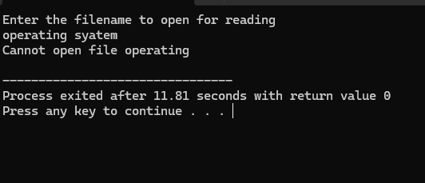
Result:
The code is successfully implemented using c program.

Experiment-3:
Aim:
To Design a CPU scheduling program with C using First Come First Served technique with the following considerations.
Program:
#include <stdio.h>
typedef struct {
int process_id;
int burst_time;
int start_time;
int finish_time;
} Process;

int main() {
int n, i;
printf("Enter number of processes: ");
scanf("%d", &n);

Process processes[n];
for (i = 0; i < n; i++) {
processes[i].process_id = i + 1;
printf("Enter burst time for Process %d: ", i + 1);
scanf("%d", &processes[i].burst_time);
}
processes[0].start_time = 0;
processes[0].finish_time = processes[0].burst_time;
for (i = 1; i < n; i++) {
processes[i].start_time = processes[i - 1].finish_time;
processes[i].finish_time = processes[i].start_time + processes[i].burst_time;
}
printf("\nProcess ID\tStart Time\tFinish Time\n");
for (i = 0; i < n; i++) {
printf("%d\t\t%d\t\t%d\n", processes[i].process_id, processes[i].start_time, processes[i].finish_time);
}

return 0;
}
Output:
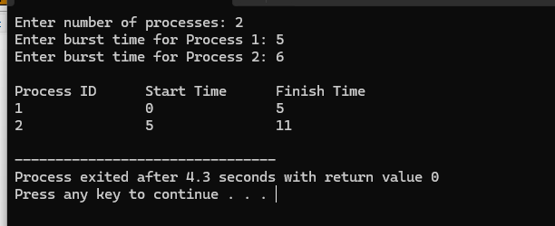
Result:
The code is successfully implemented using c program.

Experiment-4:
Aim:
To Construct a scheduling program with C that selects the waiting process with the smallest execution time to execute next.
Program:
#include <stdio.h>

struct Process {
int id;
int burst_time;
int completed;
};

void sjn_scheduling(struct Process processes[], int n) {
int completed_count = 0, current_time = 0;

while (completed_count < n) {
int min_index = -1;
for (int i = 0; i < n; i++) {
if (!processes[i].completed && (min_index == -1 || processes[i].burst_time < processes[min_index].burst_time)) {
min_index = i;
}
}

if (min_index != -1) {
current_time += processes[min_index].burst_time;
processes[min_index].completed = 1;
printf("Process %d executed at time %d\n", processes[min_index].id, current_time);
completed_count++;
}
}
}

int main() {
int n;
printf("Enter the number of processes: ");
scanf("%d", &n);

struct Process processes[n];

for (int i = 0; i < n; i++) {
processes[i].id = i + 1;
printf("Enter burst time for Process %d: ", i + 1);
scanf("%d", &processes[i].burst_time);
processes[i].completed = 0;
}

sjn_scheduling(processes, n);

return 0;
}
Output:
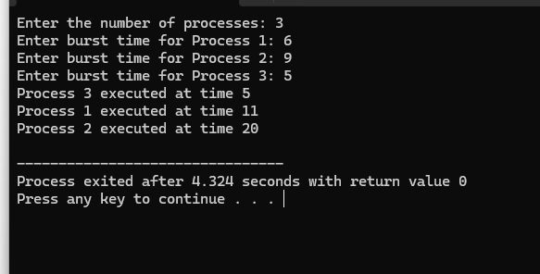
Result:
The code is successfully implemented using c program.

Experiment-5:
Aim:
To Construct a scheduling program with C that selects the waiting process with the highest priority to execute next.
Program:
#include <stdio.h>
typedef struct {
int id, priority, burstTime;
} Process;
void scheduleProcesses(Process p[], int n) {
for (int i = 0; i < n - 1; i++)
for (int j = 0; j < n - i - 1; j++)
if (p[j].priority < p[j + 1].priority) {
Process temp = p[j];
p[j] = p[j + 1];
p[j + 1] = temp;
}
}
int main() {
Process p[10];
int n;
printf("Enter number of processes: ");
scanf("%d", &n);
for (int i = 0; i < n; i++) {
printf("Enter ID, Priority, Burst Time: ");
scanf("%d %d %d", &p[i].id, &p[i].priority, &p[i].burstTime);
}
scheduleProcesses(p, n);
printf("\nScheduled Processes:\n");
for (int i = 0; i < n; i++)
printf("ID: %d, Priority: %d\n", p[i].id, p[i].priority);

return 0;
}
Output:
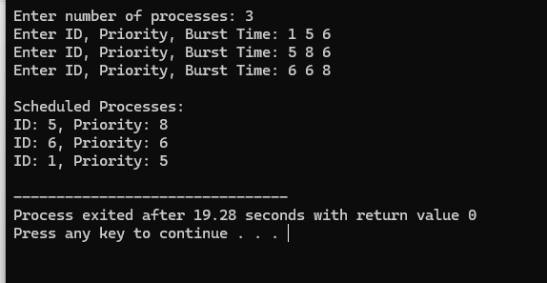
Result:
The code is successfully implemented using c program.

Experiment-6:
Aim:
To Construct a C program to implement pre-emptive priority scheduling algorithm.
Program:
#include <stdio.h>
struct Process {
int pid; // Process ID
int arrival; // Arrival time
int burst; // Burst time
int priority; // Priority
int remaining; // Remaining burst time
int waiting; // Waiting time
int turnaround; // Turnaround time
};

void priorityScheduling(struct Process proc[], int n) {
int t = 0, completed = 0;
while (completed < n) {
int minPriority = 1e9, idx = -1;
for (int i = 0; i < n; i++) {
if (proc[i].arrival <= t && proc[i].remaining > 0 && proc[i].priority < minPriority) {
minPriority = proc[i].priority;
idx = i;
}
}
if (idx != -1) {
t++;
proc[idx].remaining--;
if (proc[idx].remaining == 0) {
completed++;
proc[idx].turnaround = t - proc[idx].arrival;
proc[idx].waiting = proc[idx].turnaround - proc[idx].burst;
}
} else {
t++;
}
}
}

int main() {
struct Process proc[] = {
{1, 0, 10, 2, 10, 0, 0},
{2, 1, 5, 0, 5, 0, 0},
{3, 2, 8, 1, 8, 0, 0}
};
int n = sizeof(proc) / sizeof(proc[0]);
priorityScheduling(proc, n);
for (int i = 0; i < n; i++) {
printf("P%d: Waiting Time = %d, Turnaround Time = %d\n", proc[i].pid, proc[i].waiting, proc[i].turnaround);
}
return 0;
}
Output:
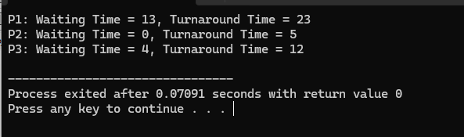
Result:
The code is successfully implemented using c program.

Exp-7:
To Construct a C program to implement non-preemptive SJF algorithm.
Program:
#include <stdio.h>

struct Process {
int pid;
int burst_time;
int waiting_time;
int turnaround_time;
};

void calculateTimes(struct Process proc[], int n) {
proc[0].waiting_time = 0;
proc[0].turnaround_time = proc[0].burst_time;
for (int i = 1; i < n; i++) {
proc[i].waiting_time = proc[i-1].waiting_time + proc[i-1].burst_time;
proc[i].turnaround_time = proc[i].waiting_time + proc[i].burst_time;
}
}

void sortProcessesByBurstTime(struct Process proc[], int n) {
for (int i = 0; i < n-1; i++) {
for (int j = 0; j < n-i-1; j++) {
if (proc[j].burst_time > proc[j+1].burst_time) {
struct Process temp = proc[j];
proc[j] = proc[j+1];
proc[j+1] = temp;
}
}
}
}

void printProcesses(struct Process proc[], int n) {
printf("PID\tBurst Time\tWaiting Time\tTurnaround Time\n");
for (int i = 0; i < n; i++) {
printf("%d\t%d\t\t%d\t\t%d\n", proc[i].pid, proc[i].burst_time, proc[i].waiting_time, proc[i].turnaround_time);
}
}

int main() {
int n;
printf("Enter number of processes: ");
scanf("%d", &n);
struct Process proc[n];

for (int i = 0; i < n; i++) {
proc[i].pid = i+1;
printf("Enter burst time for process %d: ", i+1);
scanf("%d", &proc[i].burst_time);
}

sortProcessesByBurstTime(proc, n);
calculateTimes(proc, n);
printProcesses(proc, n);

return 0;
}
Output:
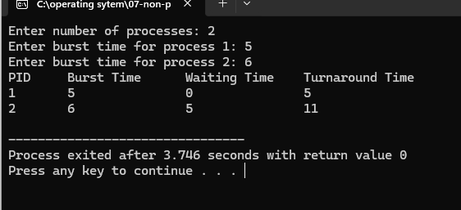
Result:
The code is successfully implemented using c program.

Experiment-8:
Aim:
To Construct a C program to simulate Round Robin scheduling algorithm with C.
Program:
#include <stdio.h>
struct Process {
int pid;
int burst_time;
int remaining_time;
int waiting_time;
int turnaround_time;
};

void calculateTimes(struct Process proc[], int n, int quantum) {
int time = 0;
int completed = 0;

while (completed < n) {
for (int i = 0; i < n; i++) {
if (proc[i].remaining_time > 0) {
if (proc[i].remaining_time > quantum) {
time += quantum;
proc[i].remaining_time -= quantum;
} else {
time += proc[i].remaining_time;
proc[i].waiting_time = time - proc[i].burst_time;
proc[i].turnaround_time = time;
proc[i].remaining_time = 0;
completed++;
}
}
}
}
}

void printProcesses(struct Process proc[], int n) {
printf("PID\tBurst Time\tWaiting Time\tTurnaround Time\n");
for (int i = 0; i < n; i++) {
printf("%d\t%d\t\t%d\t\t%d\n", proc[i].pid, proc[i].burst_time, proc[i].waiting_time, proc[i].turnaround_time);
}
}

int main() {
int n, quantum;
printf("Enter number of processes: ");
scanf("%d", &n);
struct Process proc[n];

for (int i = 0; i < n; i++) {
proc[i].pid = i+1;
printf("Enter burst time for process %d: ", i+1);
scanf("%d", &proc[i].burst_time);
proc[i].remaining_time = proc[i].burst_time;
}

printf("Enter time quantum: ");
scanf("%d", &quantum);

calculateTimes(proc, n, quantum);
printProcesses(proc, n);

return 0;
}
Output:
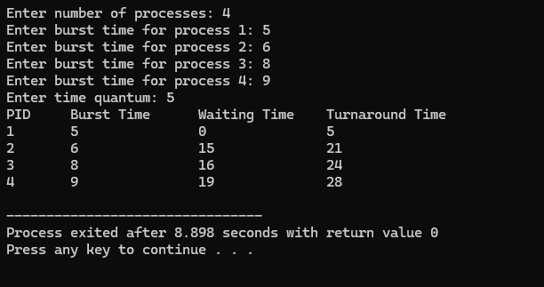
Result:
The code is successfully implemented using c program.

Experiment-9:
Aim:
To Illustrate the concept of inter-process communication using shared memory with a C program.
Program:
#include <stdio.h>
#include <stdlib.h>
#include <string.h>
#include <sys/ipc.h>
#include <sys/shm.h>
#include <sys/types.h>
#include <unistd.h>

#define SHM_SIZE 1024

int main() {
key_t key;
int shmid;
char *shmaddr;

key = ftok("shmfile", 65);
shmid = shmget(key, SHM_SIZE, 0666 | IPC_CREAT);
shmaddr = (char*) shmat(shmid, NULL, 0);

pid_t pid = fork();

if (pid < 0) {
perror("Fork failed");
exit(1);
} else if (pid == 0) {
sprintf(shmaddr, "Hello from the child process!");
shmdt(shmaddr);
exit(0);
} else {
wait(NULL);
printf("Received message: %s\n", shmaddr);
shmdt(shmaddr);
shmctl(shmid, IPC_RMID, NULL);
}

return 0;
}
Output:
Result:
The code is successfully implemented using c program.

Experiment-10:
Aim:
To Illustrate the concept of inter-process communication using message queue with a C program.
Program:
#include <stdio.h>
#include <stdlib.h>
#include <string.h>
#include <sys/ipc.h>
#include <sys/msg.h>

#define MSG_SIZE 100

struct msg_buffer {
long msg_type;
char msg_text[MSG_SIZE];
};

int main() {
key_t key;
int msgid;
struct msg_buffer message;
key = ftok("progfile", 65);
msgid = msgget(key, 0666 | IPC_CREAT);
pid_t pid = fork();

if (pid < 0) {
perror("Fork failed");
exit(1);
} else if (pid == 0) {
message.msg_type = 1;
strcpy(message.msg_text, "Hello from the child process!");
msgsnd(msgid, &message, sizeof(message.msg_text), 0);
exit(0);
} else {
msgrcv(msgid, &message, sizeof(message.msg_text), 1, 0);
printf("Received message: %s\n", message.msg_text);
msgctl(msgid, IPC_RMID, NULL);
}

return 0;
}

Output:
Result:
The code is successfully implemented using c program.

Experiment-11:
Aim:
To Illustrate the concept of multithreading using a C program.
Program:
#include <stdio.h>
#include <pthread.h>
void* threadFunction(void* arg) {
printf("Thread %d is running.\n", *(int*)arg);
return NULL;
}

int main() {
pthread_t threads[3];
int args[3] = {1, 2, 3};

for (int i = 0; i < 3; i++)
pthread_create(&threads[i], NULL, threadFunction, &args[i]);

for (int i = 0; i < 3; i++)
pthread_join(threads[i], NULL);

return 0;
}
Output:
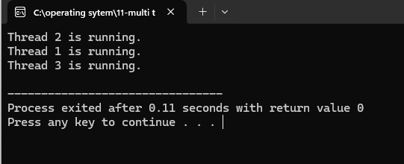
Result:
The code is successfully implemented using c program.

Experiment-12:
Aim:
To Design a C program to simulate the concept of Dining-Philosophers problem
Program:
#include <stdio.h>
#include <pthread.h>
#include <unistd.h>

#define N 2
#define ITERATIONS 1
pthread_mutex_t chopsticks[N];

void* philosopher(void* num) {
int id = *(int*)num;
for (int i = 0; i < ITERATIONS; i++) {
printf("Philosopher %d is thinking.\n", id);
sleep(1);
pthread_mutex_lock(&chopsticks[id]);
pthread_mutex_lock(&chopsticks[(id + 1) % N]);
printf("Philosopher %d is eating.\n", id);
sleep(1);
pthread_mutex_unlock(&chopsticks[(id + 1) % N]);
pthread_mutex_unlock(&chopsticks[id]);
printf("Philosopher %d finished eating.\n", id);
sleep(1);
}
return NULL;
}

int main() {
pthread_t philosophers[N];
int ids[N];
for (int i = 0; i < N; i++) {
ids[i] = i;
pthread_mutex_init(&chopsticks[i], NULL);
pthread_create(&philosophers[i], NULL, philosopher, &ids[i]);
}
for (int i = 0; i < N; i++) pthread_join(philosophers[i], NULL);
for (int i = 0; i < N; i++) pthread_mutex_destroy(&chopsticks[i]);
return 0;
}
Output:
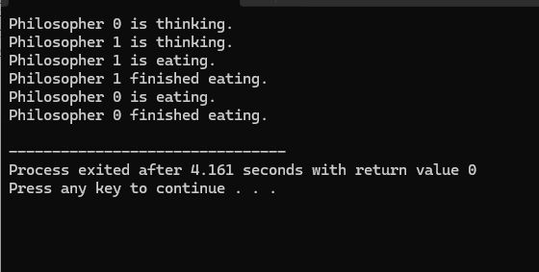
Result:
The code is successfully implemented using c program.

Experiment-13:
Aim:
To Construct a C program for implementation the various memory allocation strategies.
Program:
#include <stdio.h>
#include <stdlib.h>
#define MEMORY_SIZE 100
typedef struct Block {
int size;
int is_free;
struct Block* next;
} Block;

Block* head;

void init_memory() {
head = (Block*)malloc(sizeof(Block));
head->size = MEMORY_SIZE;
head->is_free = 1;
head->next = NULL;
}

Block* allocate(Block* (*fit)(int), int size) {
Block* b = fit(size);
if (b) b->is_free = 0;
return b;
}

Block* first_fit(int size) {
Block* b = head;
while (b) {
if (b->is_free && b->size >= size) return b;
b = b->next;
}
return NULL;
}

Block* best_fit(int size) {
Block* best = NULL;
Block* b = head;
while (b) {
if (b->is_free && b->size >= size && (!best || b->size < best->size))
best = b;
b = b->next;
}
return best;
}

Block* worst_fit(int size) {
Block* worst = NULL;
Block* b = head;
while (b) {
if (b->is_free && b->size >= size && (!worst || b->size > worst->size))
worst = b;
b = b->next;
}
return worst;
}

void free_memory(Block* b) {
if (b) b->is_free = 1;
}

void print_memory() {
Block* b = head;
while (b) {
printf("Block size: %d, is_free: %d\n", b->size, b->is_free);
b = b->next;
}
}

int main() {
init_memory();
printf("First Fit Allocation:\n");
Block* p1 = allocate(first_fit, 20);
print_memory();
printf("\nBest Fit Allocation:\n");
Block* p2 = allocate(best_fit, 20);
print_memory();
printf("\nWorst Fit Allocation:\n");
Block* p3 = allocate(worst_fit, 20);
print_memory();
printf("\nMemory after freeing:\n");
free_memory(p1);
free_memory(p2);
free_memory(p3);
print_memory();
return 0;
}
Output:
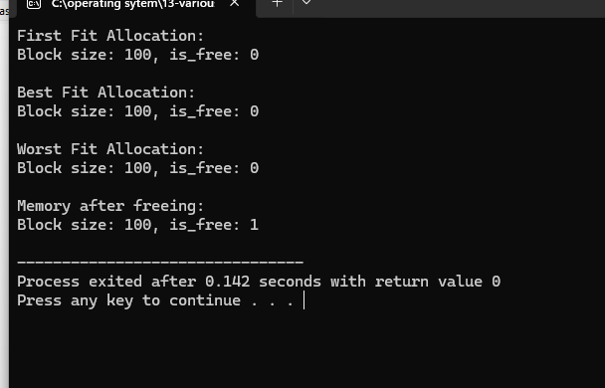
Result:
The code is successfully implemented using c program.

Experiment-14:
Aim:
To Construct a C program to organize the file using single level directory.
Program:
#include <stdio.h>
#include <stdlib.h>
#include <sys/stat.h>
#include <sys/types.h>
#include <unistd.h>

int main() {
char *directory = "single_level_dir";
char filepath[100];
char *files[] = {"file1.txt", "file2.txt", "file3.txt"};

mkdir(directory, 0777);

for (int i = 0; i < 3; ++i) {
snprintf(filepath, sizeof(filepath), "%s/%s", directory, files[i]);
FILE *file = fopen(filepath, "w");
if (file) {
fprintf(file, "This is %s\n", files[i]);
fclose(file);
}
}

return 0;
}

Output:
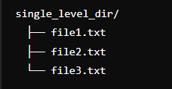
Result:
The code is successfully implemented using c program.

Experiment-15:
Aim:
To Design a C program to organize the file using two level directory structure.

Program:
#include <stdio.h>
#include <stdlib.h>
#include <sys/stat.h>
#include <sys/types.h>
#include <unistd.h>

int main() {
char *directories[] = {"dir1", "dir2"};
char *subdirectories[] = {"subdir1", "subdir2"};
char filepath[100];

for (int i = 0; i < 2; ++i) {
mkdir(directories[i], 0777);
for (int j = 0; j < 2; ++j) {
snprintf(filepath, sizeof(filepath), "%s/%s", directories[i], subdirectories[j]);
mkdir(filepath, 0777);
snprintf(filepath, sizeof(filepath), "%s/%s/file.txt", directories[i], subdirectories[j]);
FILE *file = fopen(filepath, "w");
if (file) {
fprintf(file, "This is a file in %s/%s\n", directories[i], subdirectories[j]);
fclose(file);
}
}
}

return 0;
}

Output:
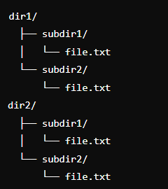
Result:
The code is successfully implemented using c program.

Experiment-16:
Aim:
To Develop a C program for implementing random access file for processing the employee details
Program:
#include <stdio.h>
#include <stdlib.h>
#include <string.h>

#define FILE_NAME "employees.dat"
#define RECORD_SIZE sizeof(Employee)

typedef struct {
int id;
char name[50];
float salary;
} Employee;

void writeRecord(int position, Employee emp) {
FILE *file = fopen(FILE_NAME, "r+");
if (file == NULL) {
printf("Unable to open file.\n");
exit(1);
}
fseek(file, position * RECORD_SIZE, SEEK_SET);
fwrite(&emp, RECORD_SIZE, 1, file);
fclose(file);
}

void readRecord(int position) {
FILE *file = fopen(FILE_NAME, "r");
if (file == NULL) {
printf("Unable to open file.\n");
exit(1);
}
Employee emp;
fseek(file, position * RECORD_SIZE, SEEK_SET);
fread(&emp, RECORD_SIZE, 1, file);
fclose(file);

printf("Employee ID: %d\n", emp.id);
printf("Employee Name: %s\n", emp.name);
printf("Employee Salary: %.2f\n", emp.salary);
}

void addRecord() {
FILE *file = fopen(FILE_NAME, "ab");
if (file == NULL) {
printf("Unable to open file.\n");
exit(1);
}
Employee emp;
printf("Enter employee ID: ");
scanf("%d", &emp.id);
printf("Enter employee name: ");
scanf(" %[^\n]", emp.name); // Read string with spaces
printf("Enter employee salary: ");
scanf("%f", &emp.salary);
fwrite(&emp, RECORD_SIZE, 1, file);
fclose(file);
}

int main() {
int choice, position;
while (1) {
printf("1. Add Record\n");
printf("2. Read Record\n");
printf("3. Update Record\n");
printf("4. Exit\n");
printf("Enter your choice: ");
scanf("%d", &choice);

switch (choice) {
case 1:
addRecord();
break;
case 2:
printf("Enter position of record to read: ");
scanf("%d", &position);
readRecord(position);
break;
case 3:
printf("Enter position of record to update: ");
scanf("%d", &position);
Employee emp;
printf("Enter new employee ID: ");
scanf("%d", &emp.id);
printf("Enter new employee name: ");
scanf(" %[^\n]", emp.name);
printf("Enter new employee salary: ");
scanf("%f", &emp.salary);
writeRecord(position, emp);
break;
case 4:
exit(0);
default:
printf("Invalid choice.\n");
}
}
return 0;
}
Output:
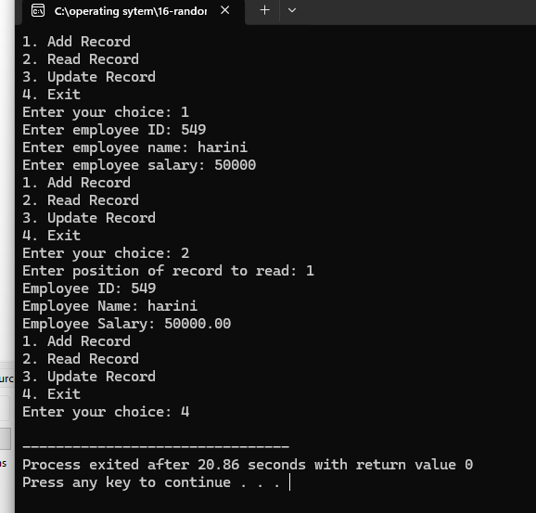
Result:
The code is successfully implemented using c program.

Experiment-17:
Aim:
To llustrate the deadlock avoidance concept by simulating Banker’s algorithm
Program:
#include <stdio.h>
#include <stdbool.h>
#define P 5
#define R 3

int available[R] = {10, 5, 7};
int max[P][R] = {
{7, 5, 3},
{3, 2, 2},
{9, 0, 2},
{2, 2, 2},
{4, 3, 3}
};
int allot[P][R] = {
{0, 1, 0},
{2, 0, 0},
{3, 0, 2},
{2, 1, 1},
{0, 0, 2}
};

void calculateNeed(int need[][R]) {
for (int i = 0; i < P; i++)
for (int j = 0; j < R; j++)
need[i][j] = max[i][j] - allot[i][j];
}

bool isSafe(int need[][R]) {
bool finish[P] = {0};
int safeSeq[P];
int work[R];

for (int i = 0; i < R; i++)
work[i] = available[i];

int count = 0;
while (count < P) {
bool found = false;
for (int p = 0; p < P; p++) {
if (!finish[p]) {
int j;
for (j = 0; j < R; j++)
if (need[p][j] > work[j])
break;

if (j == R) {
for (int k = 0; k < R; k++)
work[k] += allot[p][k];

safeSeq[count++] = p;
finish[p] = 1;
found = true;
}
}
}

if (!found) {
printf("System is not in a safe state.\n");
return false;
}
}

printf("System is in a safe state.\nSafe sequence is: ");
for (int i = 0; i < P; i++)
printf("%d ", safeSeq[i]);
printf("\n");

return true;
}

bool requestResources(int process, int request[]) {
int need[P][R];
calculateNeed(need);

for (int i = 0; i < R; i++)
if (request[i] > need[process][i])
return false;

for (int i = 0; i < R; i++)
if (request[i] > available[i])
return false;

for (int i = 0; i < R; i++) {
available[i] -= request[i];
allot[process][i] += request[i];
}

if (isSafe(need))
return true;
else {
for (int i = 0; i < R; i++) {
available[i] += request[i];
allot[process][i] -= request[i];
}
return false;
}
}

int main() {
int request[R];
int process;

printf("Enter process number (0-%d): ", P-1);
scanf("%d", &process);

printf("Enter request for %d resources: ", R);
for (int i = 0; i < R; i++)
scanf("%d", &request[i]);

if (requestResources(process, request))
printf("Request granted.\n");
else
printf("Request denied.\n");

return 0;
}
Output:
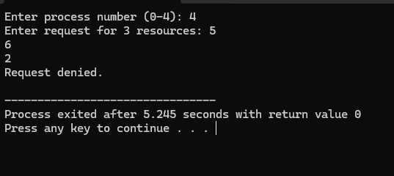
Result:
The code is successfully implemented using c program.

Experiment-18:
Aim:
To Construct a C program to simulate producer-consumer problem using semaphores.
Program:
#include <stdio.h>
#include <pthread.h>
#include <semaphore.h>
#include <stdlib.h>
#include <unistd.h>

#define BUFFER_SIZE 10
#define PRODUCER_COUNT 2
#define CONSUMER_COUNT 2
#define ITEMS_TO_PRODUCE 10

sem_t empty;
sem_t full;
pthread_mutex_t mutex;

int buffer[BUFFER_SIZE];
int in = 0;
int out = 0;

typedef struct {
int id;
} ThreadArg;

void *producer(void *arg) {
ThreadArg *targ = (ThreadArg *)arg;
int id = targ->id;

for (int i = 0; i < ITEMS_TO_PRODUCE; i++) {
sem_wait(&empty);
pthread_mutex_lock(&mutex);

buffer[in] = i;
printf("Producer %d produced %d\n", id, buffer[in]);
in = (in + 1) % BUFFER_SIZE;

pthread_mutex_unlock(&mutex);
sem_post(&full);

sleep(rand() % 2);
}
return NULL;
}

void *consumer(void *arg) {
ThreadArg *targ = (ThreadArg *)arg;
int id = targ->id;

for (int i = 0; i < ITEMS_TO_PRODUCE; i++) {
sem_wait(&full);
pthread_mutex_lock(&mutex);

int item = buffer[out];
printf("Consumer %d consumed %d\n", id, item);
out = (out + 1) % BUFFER_SIZE;

pthread_mutex_unlock(&mutex);
sem_post(&empty);

sleep(rand() % 2);
}
return NULL;
}

int main() {
pthread_t producers[PRODUCER_COUNT], consumers[CONSUMER_COUNT];
ThreadArg producer_args[PRODUCER_COUNT];
ThreadArg consumer_args[CONSUMER_COUNT];

sem_init(&empty, 0, BUFFER_SIZE);
sem_init(&full, 0, 0);
pthread_mutex_init(&mutex, NULL);

for (int i = 0; i < PRODUCER_COUNT; i++) {
producer_args[i].id = i + 1;
pthread_create(&producers[i], NULL, producer, &producer_args[i]);
}

for (int i = 0; i < CONSUMER_COUNT; i++) {
consumer_args[i].id = i + 1;
pthread_create(&consumers[i], NULL, consumer, &consumer_args[i]);
}

for (int i = 0; i < PRODUCER_COUNT; i++) {
pthread_join(producers[i], NULL);
}

for (int i = 0; i < CONSUMER_COUNT; i++) {
pthread_join(consumers[i], NULL);
}

sem_destroy(&empty);
sem_destroy(&full);
pthread_mutex_destroy(&mutex);

return 0;
}
Output:
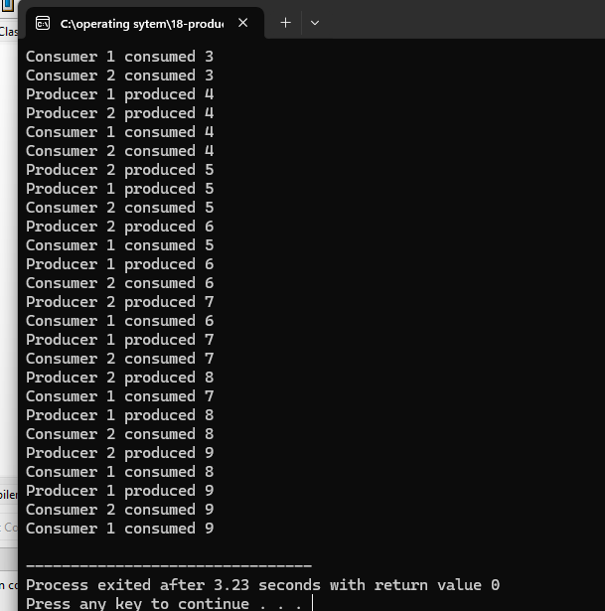
Result:
The code is successfully implemented using c program.

Experiment-19:
Aim:
To Design a C program to implement process synchronization using mutex locks.
Program:
#include <stdio.h>
#include <pthread.h>

#define NUM_THREADS 5
pthread_mutex_t mutex;
int shared_resource = 0;
void *thread_function(void *arg) {
int thread_id = *((int *)arg);

pthread_mutex_lock(&mutex);
printf("Thread %d: Accessing shared resource\n", thread_id);
shared_resource++;
printf("Thread %d: Shared resource value: %d\n", thread_id, shared_resource);
pthread_mutex_unlock(&mutex);

return NULL;
}

int main() {
pthread_t threads[NUM_THREADS];
int thread_ids[NUM_THREADS];

pthread_mutex_init(&mutex, NULL);

for (int i = 0; i < NUM_THREADS; i++) {
thread_ids[i] = i + 1;
pthread_create(&threads[i], NULL, thread_function, &thread_ids[i]);
}

for (int i = 0; i < NUM_THREADS; i++) {
pthread_join(threads[i], NULL);
}
pthread_mutex_destroy(&mutex);
return 0;
}
Output:
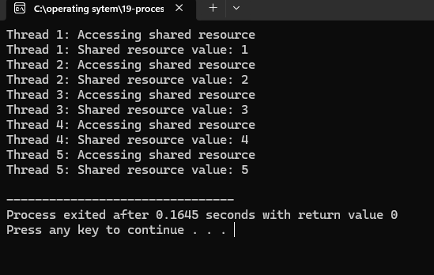
Result:
The code is successfully implemented using c program.

Experiment-20:
Aim:
To Construct a C program to simulate Reader-Writer problem using Semaphores.
Program:
#include <stdio.h>
#include <pthread.h>
#include <semaphore.h>

sem_t mutex, wrt;
int readcount = 0;

void *reader(void *arg) {
int id = *((int *)arg);
sem_wait(&mutex);
readcount++;
if (readcount == 1) sem_wait(&wrt);
sem_post(&mutex);

printf("Reader %d is reading\n", id);

sem_wait(&mutex);
readcount--;
if (readcount == 0) sem_post(&wrt);
sem_post(&mutex);
return NULL;
}

void *writer(void *arg) {
int id = *((int *)arg);
sem_wait(&wrt);
printf("Writer %d is writing\n", id);
sem_post(&wrt);
return NULL;
}

int main() {
pthread_t r, w;
int id = 1;

sem_init(&mutex, 0, 1);
sem_init(&wrt, 0, 1);

pthread_create(&r, NULL, reader, &id);
pthread_create(&w, NULL, writer, &id);

pthread_join(r, NULL);
pthread_join(w, NULL);

sem_destroy(&mutex);
sem_destroy(&wrt);
return 0;
}
Output:
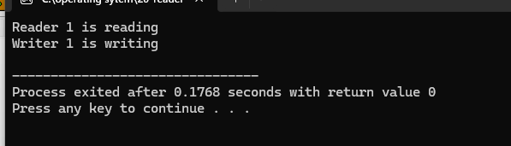
Result:
The code is successfully implemented using c program.

Experiment 21-
Aim: Develop a C program to implement worst fit algorithm of memory management.
Program:
#include <stdio.h>
#include <stdlib.h>
#include <limits.h>
#define MEMORY_SIZE 100
#define BLOCK_SIZE 10
typedef struct {
int start;
int size;
int is_allocated;
} MemoryBlock;
void initialize_memory(MemoryBlock memory[], int num_blocks) {
for (int i = 0; i < num_blocks; i++) {
memory[i].start = i * BLOCK_SIZE;
memory[i].size = BLOCK_SIZE;
memory[i].is_allocated = 0;
}
}

int allocate_memory(MemoryBlock memory[], int num_blocks, int request_size) {
int num_blocks_needed = (request_size + BLOCK_SIZE - 1) / BLOCK_SIZE;

int worst_fit_index = -1;
int max_size = -1;
int start_block = -1;
int count = 0;

for (int i = 0; i < num_blocks; i++) {
if (memory[i].is_allocated == 0) {
if (start_block == -1) {
start_block = i;
}
count++;
if (count == num_blocks_needed) {
int total_size = (i - start_block + 1) * BLOCK_SIZE;
if (total_size > max_size) {
max_size = total_size;
worst_fit_index = start_block;
}
start_block = -1;
count = 0;
}
} else {
start_block = -1;
count = 0;
}
}

if (worst_fit_index != -1) {
for (int j = worst_fit_index; j < worst_fit_index + num_blocks_needed; j++) {
memory[j].is_allocated = 1;
}
return memory[worst_fit_index].start;
}

return -1;
}

void free_memory(MemoryBlock memory[], int num_blocks, int start_address) {
int start_block = start_address / BLOCK_SIZE;

for (int i = start_block; i < num_blocks && memory[i].start < start_address + BLOCK_SIZE; i++) {
if (memory[i].start >= start_address) {
memory[i].is_allocated = 0;
}
}
}

void print_memory(MemoryBlock memory[], int num_blocks) {
printf("Memory Status:\n");
for (int i = 0; i < num_blocks; i++) {
printf("Block %d: Start = %d, Size = %d, %s\n",
i, memory[i].start, memory[i].size,
memory[i].is_allocated ? "Allocated" : "Free");
}
}

int main() {
int num_blocks = MEMORY_SIZE / BLOCK_SIZE;
MemoryBlock memory[num_blocks];
initialize_memory(memory, num_blocks);

printf("Initial ");
print_memory(memory, num_blocks);

int request_size = 25;
printf("\nAllocating %d bytes of memory...\n", request_size);
int address = allocate_memory(memory, num_blocks, request_size);
if (address != -1) {
printf("Memory allocated at address %d\n", address);
} else {
printf("Failed to allocate memory\n");
}

print_memory(memory, num_blocks);

printf("\nFreeing memory at address %d...\n", address);
free_memory(memory, num_blocks, address);

print_memory(memory, num_blocks);

return 0;
}
Output:
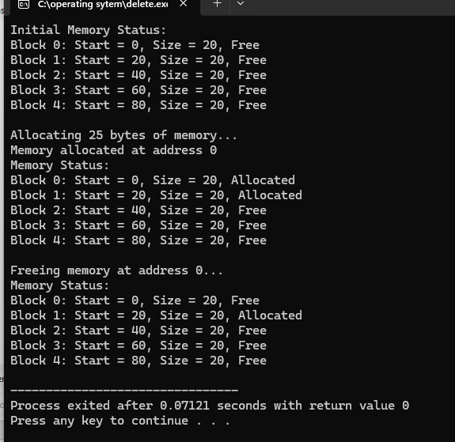

Result:
The code is successfully implemented using c program.

Eperiment-22
Aim:Construct a C program to implement best fit algorithm of memory management.

Program:
#include <stdio.h>
#include <stdlib.h>
#include <limits.h>
#define MEMORY_SIZE 100
#define BLOCK_SIZE 10
typedef struct {
int start;
int size;
int is_allocated;
} MemoryBlock;

void initialize_memory(MemoryBlock memory[], int num_blocks) {
for (int i = 0; i < num_blocks; i++) {
memory[i].start = i * BLOCK_SIZE;
memory[i].size = BLOCK_SIZE;
memory[i].is_allocated = 0;
}
}

int allocate_memory(MemoryBlock memory[], int num_blocks, int request_size) {
int num_blocks_needed = (request_size + BLOCK_SIZE - 1) / BLOCK_SIZE;

int best_fit_index = -1;
int min_size_diff = INT_MAX;
int start_block = -1;
int count = 0;

for (int i = 0; i < num_blocks; i++) {
if (memory[i].is_allocated == 0) {
if (start_block == -1) {
start_block = i;
}
count++;
if (count == num_blocks_needed) {
int total_size = (i - start_block + 1) * BLOCK_SIZE;
int size_diff = total_size - request_size;
if (size_diff < min_size_diff) {
min_size_diff = size_diff;
best_fit_index = start_block;
}
start_block = -1;
count = 0;
}
} else {
start_block = -1;
count = 0;
}
}

if (best_fit_index != -1) {
for (int j = best_fit_index; j < best_fit_index + num_blocks_needed; j++) {
memory[j].is_allocated = 1;
}
return memory[best_fit_index].start;
}

return -1;
}

void free_memory(MemoryBlock memory[], int num_blocks, int start_address) {
int start_block = start_address / BLOCK_SIZE;

for (int i = start_block; i < num_blocks && memory[i].start < start_address + BLOCK_SIZE; i++) {
if (memory[i].start >= start_address) {
memory[i].is_allocated = 0;
}
}
}

void print_memory(MemoryBlock memory[], int num_blocks) {
printf("Memory Status:\n");
for (int i = 0; i < num_blocks; i++) {
printf("Block %d: Start = %d, Size = %d, %s\n",
i, memory[i].start, memory[i].size,
memory[i].is_allocated ? "Allocated" : "Free");
}
}

int main() {
int num_blocks = MEMORY_SIZE / BLOCK_SIZE;
MemoryBlock memory[num_blocks];
initialize_memory(memory, num_blocks);

printf("Initial ");
print_memory(memory, num_blocks);

int request_size = 25;
printf("\nAllocating %d bytes of memory...\n", request_size);
int address = allocate_memory(memory, num_blocks, request_size);
if (address != -1) {
printf("Memory allocated at address %d\n", address);
} else {
printf("Failed to allocate memory\n");
}

print_memory(memory, num_blocks);

printf("\nFreeing memory at address %d...\n", address);
free_memory(memory, num_blocks, address);

print_memory(memory, num_blocks);

return 0;
}
Output:
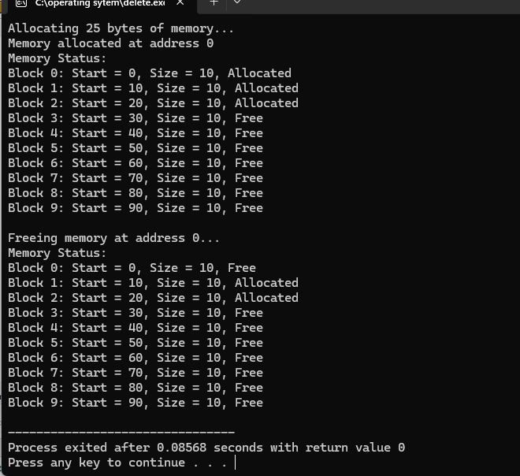
Result:
The code is successfully implemented using c program.

Experiment-23:
Aim:Construct a C program to implement first fit algorithm of memory management
Program:
#include <stdio.h>
#include <stdlib.h>
#include <string.h>

#define MEMORY_SIZE 100
#define BLOCK_SIZE 10

typedef struct {
int start;
int size;
int is_allocated;
} MemoryBlock;

void initialize_memory(MemoryBlock memory[], int num_blocks) {
for (int i = 0; i < num_blocks; i++) {
memory[i].start = i * BLOCK_SIZE;
memory[i].size = BLOCK_SIZE;
memory[i].is_allocated = 0;
}
}

int allocate_memory(MemoryBlock memory[], int num_blocks, int request_size) {
int num_blocks_needed = (request_size + BLOCK_SIZE - 1) / BLOCK_SIZE;

int start_block = -1;
int count = 0;

for (int i = 0; i < num_blocks; i++) {
if (memory[i].is_allocated == 0) {
if (start_block == -1) {
start_block = i;
}
count++;
if (count == num_blocks_needed) {
for (int j = start_block; j <= i; j++) {
memory[j].is_allocated = 1;
}
return start_block * BLOCK_SIZE;
}
} else {
start_block = -1;
count = 0;
}
}

return -1;
}

void free_memory(MemoryBlock memory[], int num_blocks, int start_address) {
int start_block = start_address / BLOCK_SIZE;

for (int i = start_block; i < num_blocks && memory[i].start < start_address + BLOCK_SIZE; i++) {
if (memory[i].start >= start_address) {
memory[i].is_allocated = 0;
}
}
}

void print_memory(MemoryBlock memory[], int num_blocks) {
printf("Memory Status:\n");
for (int i = 0; i < num_blocks; i++) {
printf("Block %d: Start = %d, Size = %d, %s\n",
i, memory[i].start, memory[i].size,
memory[i].is_allocated ? "Allocated" : "Free");
}
}

int main() {
int num_blocks = MEMORY_SIZE / BLOCK_SIZE;
MemoryBlock memory[num_blocks];
initialize_memory(memory, num_blocks);

printf("Initial ");
print_memory(memory, num_blocks);

int request_size = 25;
printf("\nAllocating %d bytes of memory...\n", request_size);
int address = allocate_memory(memory, num_blocks, request_size);
if (address != -1) {
printf("Memory allocated at address %d\n", address);
} else {
printf("Failed to allocate memory\n");
}

print_memory(memory, num_blocks);

printf("\nFreeing memory at address %d...\n", address);
free_memory(memory, num_blocks, address);

print_memory(memory, num_blocks);

return 0;
}
Output:
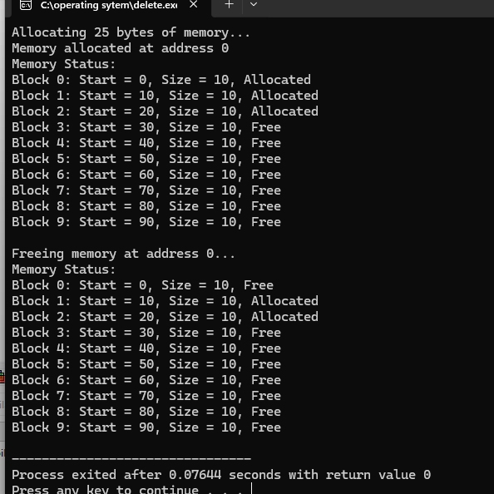
Result:
The code is successfully implemented using c program.
Experiment-24:
Aim:Design a C program to demonstrate UNIX system calls for file management.
Program:
#include <stdio.h>
#include <stdlib.h>
#include <fcntl.h>
#include <unistd.h>
#include <sys/stat.h>
#include <sys/types.h>
#include <errno.h>
#include <string.h>

#define BUFFER_SIZE 1024

void create_and_write_file(const char *filename, const char *content) {
// Create and open a file with read-write permissions
int fd = open(filename, O_WRONLY | O_CREAT | O_TRUNC, S_IRUSR | S_IWUSR);
if (fd < 0) {
perror("Error opening file for writing");
exit(EXIT_FAILURE);
}

// Write content to the file
ssize_t bytes_written = write(fd, content, strlen(content));
if (bytes_written < 0) {
perror("Error writing to file");
close(fd);
exit(EXIT_FAILURE);
}

printf("Written %ld bytes to '%s'.\n", (long)bytes_written, filename);

// Close the file
if (close(fd) < 0) {
perror("Error closing file");
exit(EXIT_FAILURE);
}
}

void read_file(const char *filename) {
// Open the file for reading
int fd = open(filename, O_RDONLY);
if (fd < 0) {
perror("Error opening file for reading");
exit(EXIT_FAILURE);
}

char buffer[BUFFER_SIZE];
ssize_t bytes_read;

// Read from the file
while ((bytes_read = read(fd, buffer, sizeof(buffer) - 1)) > 0) {
buffer[bytes_read] = '\0'; // Null-terminate the buffer
printf("Read: %s", buffer);
}

if (bytes_read < 0) {
perror("Error reading from file");
close(fd);
exit(EXIT_FAILURE);
}

// Close the file
if (close(fd) < 0) {
perror("Error closing file");
exit(EXIT_FAILURE);
}
}

void get_file_info(const char *filename) {
struct stat file_info;

// Get file information
if (stat(filename, &file_info) < 0) {
perror("Error getting file information");
exit(EXIT_FAILURE);
}

printf("File size: %ld bytes\n", (long)file_info.st_size);
printf("File permissions: %o\n", file_info.st_mode & (S_IRWXU | S_IRWXG | S_IRWXO));
}

int main() {
const char *filename = "example.txt";
const char *content = "This is a sample text for file management demonstration.\n";

// Create and write to the file
create_and_write_file(filename, content);

// Read from the file
printf("\nReading file contents:\n");
read_file(filename);

// Get file information
get_file_info(filename);

return 0;
}

Output:

Result:
The code is successfully implemented using c program.
Experiment-25:
Aim:Construct a C program to implement the I/O system calls of UNIX (fcntl, seek, stat, opendir, readdir)
Program:
#include <stdio.h>
#include <stdlib.h>
#include <string.h>

// Function to create and write to a file
void create_and_write_file(const char *filename, const char *content) {
// Open the file for writing. If the file does not exist, it will be created.
FILE *file = fopen(filename, "w");
if (file == NULL) {
perror("Error creating file");
exit(EXIT_FAILURE);
}
// Write the content to the file
fprintf(file, "%s", content);
// Close the file
fclose(file);
printf("File '%s' created and written successfully.\n", filename);
}

// Function to read from a file
void read_file(const char *filename) {
// Open the file for reading
FILE *file = fopen(filename, "r");
if (file == NULL) {
perror("Error opening file");
exit(EXIT_FAILURE);
}
char buffer[256];
// Print the contents of the file
printf("Contents of '%s':\n", filename);
while (fgets(buffer, sizeof(buffer), file) != NULL) {
printf("%s", buffer);
}
// Close the file
fclose(file);
}

// Function to delete a file
void delete_file(const char *filename) {
// Remove the file from the filesystem
if (remove(filename) == 0) {
printf("File '%s' deleted successfully.\n", filename);
} else {
perror("Error deleting file");
}
}

int main() {
const char *filename = "example.txt";
const char *content = "This is a sample text for file management.\n";

// Create and write to the file
create_and_write_file(filename, content);

// Read from the file
read_file(filename);

// Delete the file
delete_file(filename);

return 0;
}
#include <stdio.h>
#include <stdlib.h>
#include <fcntl.h>
#include <unistd.h>
#include <sys/stat.h>
#include <sys/types.h>
#include <dirent.h>
#include <errno.h>

// Function to demonstrate the use of fcntl
void demo_fcntl(const char *filename) {
int fd = open(filename, O_RDONLY);
if (fd < 0) {
perror("Error opening file with open");
exit(EXIT_FAILURE);
}

int flags = fcntl(fd, F_GETFL);
if (flags == -1) {
perror("Error getting file flags");
close(fd);
exit(EXIT_FAILURE);
}

printf("File descriptor flags: %d\n", flags);

// Add the O_NONBLOCK flag
if (fcntl(fd, F_SETFL, O_NONBLOCK) == -1) {
perror("Error setting file to non-blocking");
close(fd);
exit(EXIT_FAILURE);
}

printf("File descriptor set to non-blocking mode.\n");

close(fd);
}

// Function to demonstrate the use of lseek
void demo_lseek(const char *filename) {
int fd = open(filename, O_RDONLY);
if (fd < 0) {
perror("Error opening file with open");
exit(EXIT_FAILURE);
}

off_t offset = lseek(fd, 0, SEEK_END);
if (offset == -1) {
perror("Error seeking to end of file");
close(fd);
exit(EXIT_FAILURE);
}

printf("File size: %ld bytes\n", (long)offset);

close(fd);
}

// Function to demonstrate the use of stat
void demo_stat(const char *filename) {
struct stat file_info;

if (stat(filename, &file_info) == -1) {
perror("Error getting file status");
exit(EXIT_FAILURE);
}

printf("File size: %ld bytes\n", (long)file_info.st_size);
printf("File permissions: %o\n", file_info.st_mode & (S_IRWXU | S_IRWXG | S_IRWXO));
}
void demo_opendir_readdir(const char *directory) {
DIR *dir = opendir(directory);
if (dir == NULL) {
perror("Error opening directory");
exit(EXIT_FAILURE);
}
struct dirent *entry;
printf("Contents of directory '%s':\n", directory);
while ((entry = readdir(dir)) != NULL) {
printf("%s\n", entry->d_name);
}
closedir(dir);
}
int main() {
const char *filename = "example.txt";
const char *directory = ".";
demo_fcntl(filename);
demo_lseek(filename);
demo_stat(filename);
demo_opendir_readdir(directory);

return 0;
}

Output:
Result:
The code is successfully implemented using c program.
Experiment-26:
Aim:Construct a C program to implement the file management operations.
Program:
#include <stdio.h>
#include <stdlib.h>
#include <string.h>
void create_and_write_file(const char *filename, const char *content) {
FILE *file = fopen(filename, "w");
if (file == NULL) {
perror("Error creating file");
exit(EXIT_FAILURE);
}
fprintf(file, "%s", content);
fclose(file);
printf("File '%s' created and written successfully.\n", filename);
}

// Function to read from a file
void read_file(const char *filename) {
FILE *file = fopen(filename, "r");
if (file == NULL) {
perror("Error opening file");
exit(EXIT_FAILURE);
}
char buffer[256];
printf("Contents of '%s':\n", filename);
while (fgets(buffer, sizeof(buffer), file) != NULL) {
printf("%s", buffer);
}
fclose(file);
}
void delete_file(const char *filename) {
if (remove(filename) == 0) {
printf("File '%s' deleted successfully.\n", filename);
} else {
perror("Error deleting file");
}
}
int main() {
const char *filename = "example.txt";
const char *content = "This is a sample text for file management.\n";

create_and_write_file(filename, content);
read_file(filename);
delete_file(filename);

return 0;
}
Output:
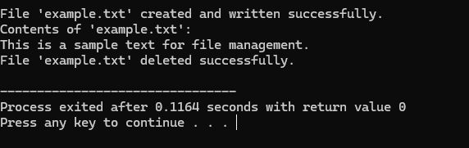
Result:
The code is successfully implemented using c program.
Experiment-27:
Aim: Develop a C program for simulating the function of ls UNIX Command.
Program:
#include <stdio.h>
#include <stdlib.h>
#include <dirent.h>
#include <errno.h>
#include <string.h>

void list_directory(const char *path) {
struct dirent *entry;
DIR *dp = opendir(path);

if (dp == NULL) {
perror("Error opening directory");
exit(EXIT_FAILURE);
}

while ((entry = readdir(dp))) {
printf("%s\n", entry->d_name);
}

closedir(dp);
}

int main(int argc, char *argv[]) {
if (argc > 2) {
fprintf(stderr, "Usage: %s [directory]\n", argv[0]);
exit(EXIT_FAILURE);
}

const char *path = (argc == 2) ? argv[1] : "."; // Default to current directory

list_directory(path);

return 0;
}
Output:
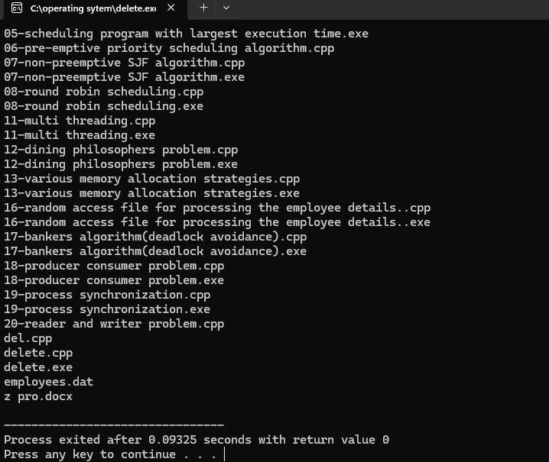
Result:
The code is successfully implemented using c program.

Experiment-28:
Aim:Write a C program for simulation of GREP UNIX command
Program:
#include <stdio.h>
#include <stdlib.h>
#include <string.h>

#define BUFFER_SIZE 1024

void grep(const char *pattern, const char *filename) {
FILE *file = fopen(filename, "r");
if (file == NULL) {
perror("Error opening file");
exit(EXIT_FAILURE);
}

char buffer[BUFFER_SIZE];
while (fgets(buffer, BUFFER_SIZE, file) != NULL) {
if (strstr(buffer, pattern) != NULL) {
printf("%s", buffer);
}
}

fclose(file);
}

int main(int argc, char *argv[]) {
if (argc != 3) {
fprintf(stderr, "Usage: %s <pattern> <filename>\n", argv[0]);
exit(EXIT_FAILURE);
}

const char *pattern = argv[1];
const char *filename = argv[2];

grep(pattern, filename);

return 0;
}
Output:
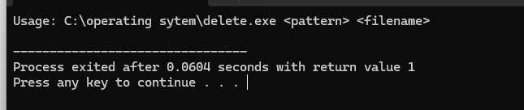
Result:
The code is successfully implemented using c program.
Experiment-29:
Aim:Write a C program to simulate the solution of Classical Process Synchronization Problem.
Program:
#include <stdio.h>
#include <pthread.h>
#include <unistd.h> // For sleep()

// Critical Section Problem
#define NUM_CS_THREADS 2
pthread_mutex_t cs_mutex;

void* critical_section(void* arg) {
int thread_id = *((int*)arg);

pthread_mutex_lock(&cs_mutex);
printf("Critical Section: Thread %d is in the critical section\n", thread_id);
sleep(1); // Simulate work
printf("Critical Section: Thread %d is leaving the critical section\n", thread_id);
pthread_mutex_unlock(&cs_mutex);

pthread_exit(NULL);
}

// Producer-Consumer Problem
#define BUFFER_SIZE 5
#define NUM_PRODUCERS 1
#define NUM_CONSUMERS 1

int buffer[BUFFER_SIZE];
int count = 0;
pthread_mutex_t pc_mutex;
pthread_cond_t pc_full;
pthread_cond_t pc_empty;

void* producer(void* arg) {
for (int i = 0; i < 10; i++) {
pthread_mutex_lock(&pc_mutex);

while (count == BUFFER_SIZE) {
pthread_cond_wait(&pc_full, &pc_mutex);
}

buffer[count] = i;
printf("Producer: Produced %d\n", i);
count++;

pthread_cond_signal(&pc_empty);
pthread_mutex_unlock(&pc_mutex);

sleep(1);
}
pthread_exit(NULL);
}

void* consumer(void* arg) {
for (int i = 0; i < 10; i++) {
pthread_mutex_lock(&pc_mutex);

while (count == 0) {
pthread_cond_wait(&pc_empty, &pc_mutex);
}

int item = buffer[count - 1];
count--;
printf("Consumer: Consumed %d\n", item);

pthread_cond_signal(&pc_full);
pthread_mutex_unlock(&pc_mutex);

sleep(2);
}
pthread_exit(NULL);
}

// Reader-Writer Problem
#define NUM_READERS 3
#define NUM_WRITERS 2

int data = 0;
int read_count = 0;
pthread_mutex_t rw_mutex;
pthread_mutex_t rw_read_mutex;
pthread_mutex_t rw_write_mutex;

void* reader(void* arg) {
int reader_id = *((int*)arg);
for (int i = 0; i < 5; i++) {
pthread_mutex_lock(&rw_read_mutex);
pthread_mutex_lock(&rw_mutex);

read_count++;
if (read_count == 1) {
pthread_mutex_lock(&rw_write_mutex);
}

pthread_mutex_unlock(&rw_mutex);
pthread_mutex_unlock(&rw_read_mutex);

printf("Reader %d: Read data = %d\n", reader_id, data);

pthread_mutex_lock(&rw_mutex);
read_count--;
if (read_count == 0) {
pthread_mutex_unlock(&rw_write_mutex);
}
pthread_mutex_unlock(&rw_mutex);

sleep(1);
}
pthread_exit(NULL);
}

void* writer(void* arg) {
int writer_id = *((int*)arg);
for (int i = 0; i < 5; i++) {
pthread_mutex_lock(&rw_write_mutex);

data++;
printf("Writer %d: Wrote data = %d\n", writer_id, data);

pthread_mutex_unlock(&rw_write_mutex);

sleep(2);
}
pthread_exit(NULL);
}

int main() {
pthread_t cs_threads[NUM_CS_THREADS];
pthread_t producers[NUM_PRODUCERS];
pthread_t consumers[NUM_CONSUMERS];
pthread_t readers[NUM_READERS];
pthread_t writers[NUM_WRITERS];

// Initialize mutexes and condition variables
pthread_mutex_init(&cs_mutex, NULL);
pthread_mutex_init(&pc_mutex, NULL);
pthread_cond_init(&pc_full, NULL);
pthread_cond_init(&pc_empty, NULL);
pthread_mutex_init(&rw_mutex, NULL);
pthread_mutex_init(&rw_read_mutex, NULL);
pthread_mutex_init(&rw_write_mutex, NULL);

// Critical Section Problem
int cs_ids[NUM_CS_THREADS];
for (int i = 0; i < NUM_CS_THREADS; i++) {
cs_ids[i] = i + 1;
pthread_create(&cs_threads[i], NULL, critical_section, (void*)&cs_ids[i]);
}
for (int i = 0; i < NUM_CS_THREADS; i++) {
pthread_join(cs_threads[i], NULL);
}

// Producer-Consumer Problem
for (int i = 0; i < NUM_PRODUCERS; i++) {
pthread_create(&producers[i], NULL, producer, NULL);
}
for (int i = 0; i < NUM_CONSUMERS; i++) {
pthread_create(&consumers[i], NULL, consumer, NULL);
}
for (int i = 0; i < NUM_PRODUCERS; i++) {
pthread_join(producers[i], NULL);
}
for (int i = 0; i < NUM_CONSUMERS; i++) {
pthread_join(consumers[i], NULL);
}

// Reader-Writer Problem
int reader_ids[NUM_READERS];
int writer_ids[NUM_WRITERS];
for (int i = 0; i < NUM_READERS; i++) {
reader_ids[i] = i + 1;
pthread_create(&readers[i], NULL, reader, (void*)&reader_ids[i]);
}
for (int i = 0; i < NUM_WRITERS; i++) {
writer_ids[i] = i + 1;
pthread_create(&writers[i], NULL, writer, (void*)&writer_ids[i]);
}
for (int i = 0; i < NUM_READERS; i++) {
pthread_join(readers[i], NULL);
}
for (int i = 0; i < NUM_WRITERS; i++) {
pthread_join(writers[i], NULL);
}

// Destroy mutexes and condition variables
pthread_mutex_destroy(&cs_mutex);
pthread_mutex_destroy(&pc_mutex);
pthread_cond_destroy(&pc_full);
pthread_cond_destroy(&pc_empty);
pthread_mutex_destroy(&rw_mutex);
pthread_mutex_destroy(&rw_read_mutex);
pthread_mutex_destroy(&rw_write_mutex);

return 0;
}
Output:
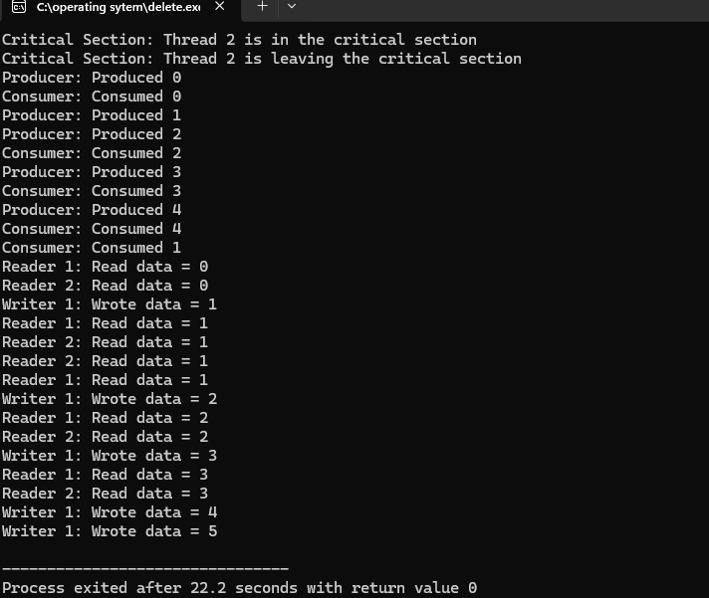
Result:
The code is successfully implemented using c program.
Experiment-30:
Aim:Write C programs to demonstrate the following thread related concepts.
- create (ii) join (iii) equal (iv) exit
Program:
#include <stdio.h>
#include <stdlib.h>
#include <pthread.h>
#include <unistd.h>
void* thread_function(void* arg) {
printf("Thread %ld is running\n", (long)arg);
sleep(1);
pthread_exit(NULL);
}
int main() {
pthread_t thread1, thread2;
int result;
result = pthread_create(&thread1, NULL, thread_function, (void*)1);
if (result != 0) {
fprintf(stderr, "Error creating thread 1\n");
exit(EXIT_FAILURE);
}
result = pthread_create(&thread2, NULL, thread_function, (void*)2);
if (result != 0) {
fprintf(stderr, "Error creating thread 2\n");
exit(EXIT_FAILURE);
}
result = pthread_join(thread1, NULL);
if (result != 0) {
fprintf(stderr, "Error joining thread 1\n");
exit(EXIT_FAILURE);
}
result = pthread_join(thread2, NULL);
if (result != 0) {
fprintf(stderr, "Error joining thread 2\n");
exit(EXIT_FAILURE);
}
if (pthread_equal(thread1, thread2)) {
printf("Thread 1 and Thread 2 are equal\n");
} else {
printf("Thread 1 and Thread 2 are not equal\n");
}

printf("Both threads have terminated\n");

return 0;
}
Output:
Result:
The code is successfully implemented using c program.
Experiment-31:
Aim:Construct a C program to simulate the First in First Out paging technique of memory management.

Program:
#include <stdio.h>
#include <stdlib.h>

#define MAX_PAGES 100
#define MAX_FRAMES 10

void fifo_paging(int page_sequence[], int num_pages, int num_frames) {
int frames[MAX_FRAMES];
int front = 0, rear = 0;
int page_faults = 0;
int page_count = 0;

// Initialize frames with -1 (indicating empty)
for (int i = 0; i < num_frames; i++) {
frames[i] = -1;
}

printf("Page Sequence: ");
for (int i = 0; i < num_pages; i++) {
printf("%d ", page_sequence[i]);
}
printf("\n");

for (int i = 0; i < num_pages; i++) {
int page = page_sequence[i];
int page_found = 0;

// Check if the page is already in one of the frames
for (int j = 0; j < num_frames; j++) {
if (frames[j] == page) {
page_found = 1;
break;
}
}

// If the page is not found, we need to replace a page
if (!page_found) {
frames[rear] = page;
rear = (rear + 1) % num_frames;
page_faults++;

printf("Page Fault: Replace page with %d\n", page);
printf("Frames: ");
for (int k = 0; k < num_frames; k++) {
if (frames[k] == -1) {
printf("_ ");
} else {
printf("%d ", frames[k]);
}
}
printf("\n");
}
}

printf("Total Page Faults: %d\n", page_faults);
}

int main() {
int page_sequence[MAX_PAGES];
int num_pages, num_frames;

printf("Enter the number of pages: ");
scanf("%d", &num_pages);

printf("Enter the page sequence: ");
for (int i = 0; i < num_pages; i++) {
scanf("%d", &page_sequence[i]);
}

printf("Enter the number of frames: ");
scanf("%d", &num_frames);

if (num_frames > MAX_FRAMES) {
printf("Number of frames exceeds maximum allowed (%d).\n", MAX_FRAMES);
return 1;
}

fifo_paging(page_sequence, num_pages, num_frames);
return 0;
}
Output:

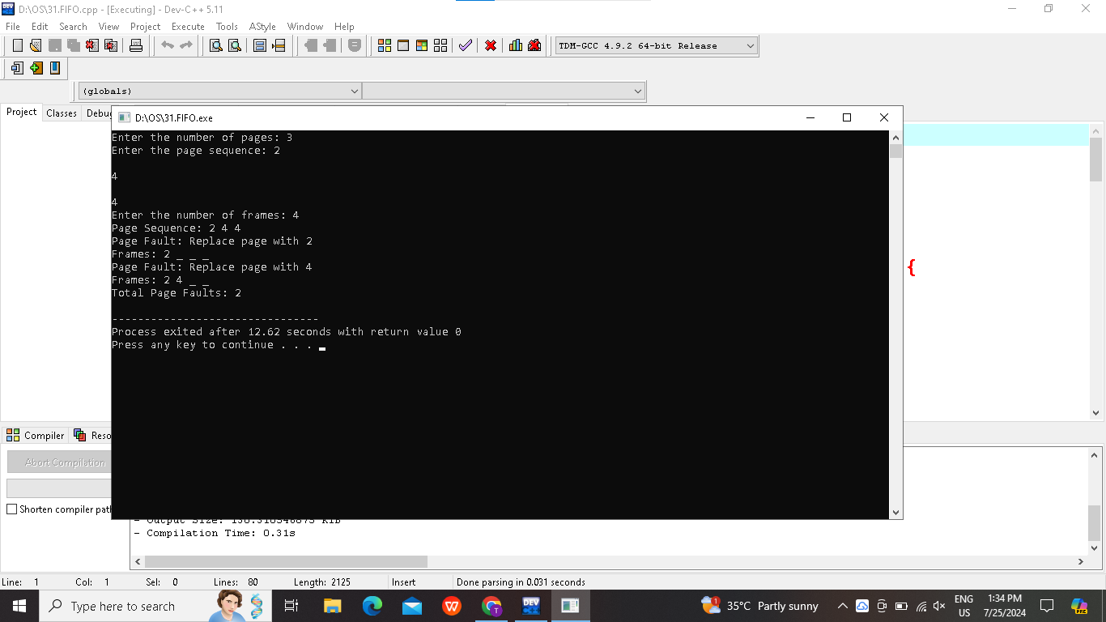
Result:
The code is successfully implemented using c program.
Experiment-32:
Aim:Construct a C program to simulate the Least Recently Used paging technique of memory management.
Program:
#include <stdio.h>
#include <stdlib.h>
#define MAX_PAGES 100
#define MAX_FRAMES 10
void lru_paging(int page_sequence[], int num_pages, int num_frames) {
int frames[MAX_FRAMES];
int last_used[MAX_FRAMES];
int page_faults = 0;
for (int i = 0; i < num_frames; i++) {
frames[i] = -1;
last_used[i] = -1;
}
printf("Page Sequence: ");
for (int i = 0; i < num_pages; i++) {
printf("%d ", page_sequence[i]);
}
printf("\n");
for (int i = 0; i < num_pages; i++) {
int page = page_sequence[i];
int page_found = 0;
int replace_index = -1;
int oldest_time = __INT_MAX__;
for (int j = 0; j < num_frames; j++) {
if (frames[j] == page) {
page_found = 1;
last_used[j] = i;
break;
}
}
if (!page_found) {
for (int j = 0; j < num_frames; j++) {
if (last_used[j] < oldest_time) {
oldest_time = last_used[j];
replace_index = j;
}
}
frames[replace_index] = page;
last_used[replace_index] = i;
page_faults++;
printf("Page Fault: Replace page with %d\n", page);
printf("Frames: ");
for (int k = 0; k < num_frames; k++) {
if (frames[k] == -1) {
printf("_ ");
} else {
printf("%d ", frames[k]);
}
}
printf("\n");
}
}
printf("Total Page Faults: %d\n", page_faults);
}
int main() {
int page_sequence[MAX_PAGES];
int num_pages, num_frames;
printf("Enter the number of pages: ");
scanf("%d", &num_pages);
printf("Enter the page sequence: ");
for (int i = 0; i < num_pages; i++) {
scanf("%d", &page_sequence[i]);
}
printf("Enter the number of frames: ");
scanf("%d", &num_frames);
if (num_frames > MAX_FRAMES) {
printf("Number of frames exceeds maximum allowed (%d).\n", MAX_FRAMES);
return 1;
}
lru_paging(page_sequence, num_pages, num_frames);
return 0;
}
Output:
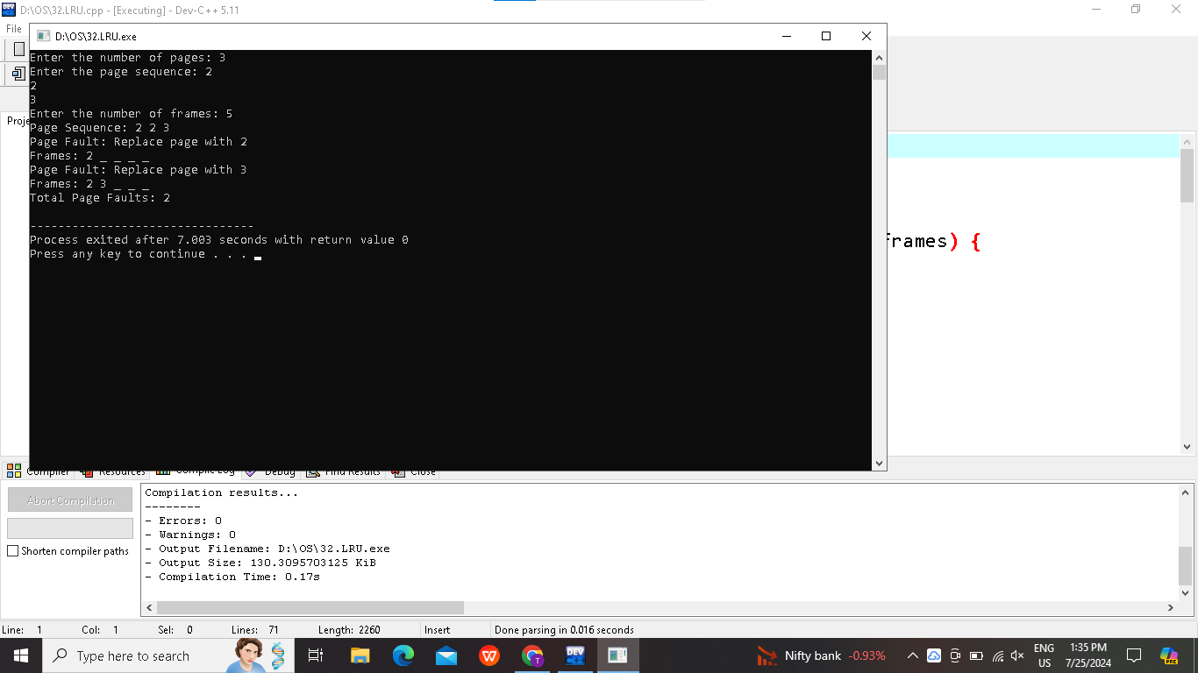
Result:
The code is successfully implemented using c program.
Experiment-33:
Aim:Construct a C program to simulate the optimal paging technique of memory management
Program:

#include <stdio.h>
#include <limits.h>
#define MAX_PAGES 100
#define MAX_FRAMES 10
int find_optimal_page(int frames[], int page_sequence[], int current_index, int num_frames, int num_pages) {
int farthest = current_index;
int page_to_replace = -1;
for (int i = 0; i < num_frames; i++) {
int j;
for (j = current_index; j < num_pages; j++) {
if (frames[i] == page_sequence[j]) {
if (j > farthest) {
farthest = j;
page_to_replace = i;
}
break;
}
}
if (j == num_pages) {
return i;
}
}
return page_to_replace;
}
void optimal_paging(int page_sequence[], int num_pages, int num_frames) {
int frames[MAX_FRAMES];
int page_faults = 0;
for (int i = 0; i < num_frames; i++) {
frames[i] = -1;
}
printf("Page Sequence: ");
for (int i = 0; i < num_pages; i++) {
printf("%d ", page_sequence[i]);
}
printf("\n");
for (int i = 0; i < num_pages; i++) {
int page = page_sequence[i];
int page_found = 0;
for (int j = 0; j < num_frames; j++) {
if (frames[j] == page) {
page_found = 1;
break;
}
}
if (!page_found) {
int replace_index = find_optimal_page(frames, page_sequence, i, num_frames, num_pages);
frames[replace_index] = page;
page_faults++;
printf("Page Fault: Replace page with %d\n", page);
printf("Frames: ");
for (int k = 0; k < num_frames; k++) {
if (frames[k] == -1) {
printf("_ ");
} else {
printf("%d ", frames[k]);
}
}
printf("\n");
}
}
printf("Total Page Faults: %d\n", page_faults);
}
int main() {
int page_sequence[MAX_PAGES];
int num_pages, num_frames;
printf("Enter the number of pages: ");
scanf("%d", &num_pages);
printf("Enter the page sequence: ");
for (int i = 0; i < num_pages; i++) {
scanf("%d", &page_sequence[i]);
}
printf("Enter the number of frames: ");
scanf("%d", &num_frames);
if (num_frames > MAX_FRAMES) {
printf("Number of frames exceeds maximum allowed (%d).\n", MAX_FRAMES);
return 1;
}
optimal_paging(page_sequence, num_pages, num_frames);
return 0;
}
Output:
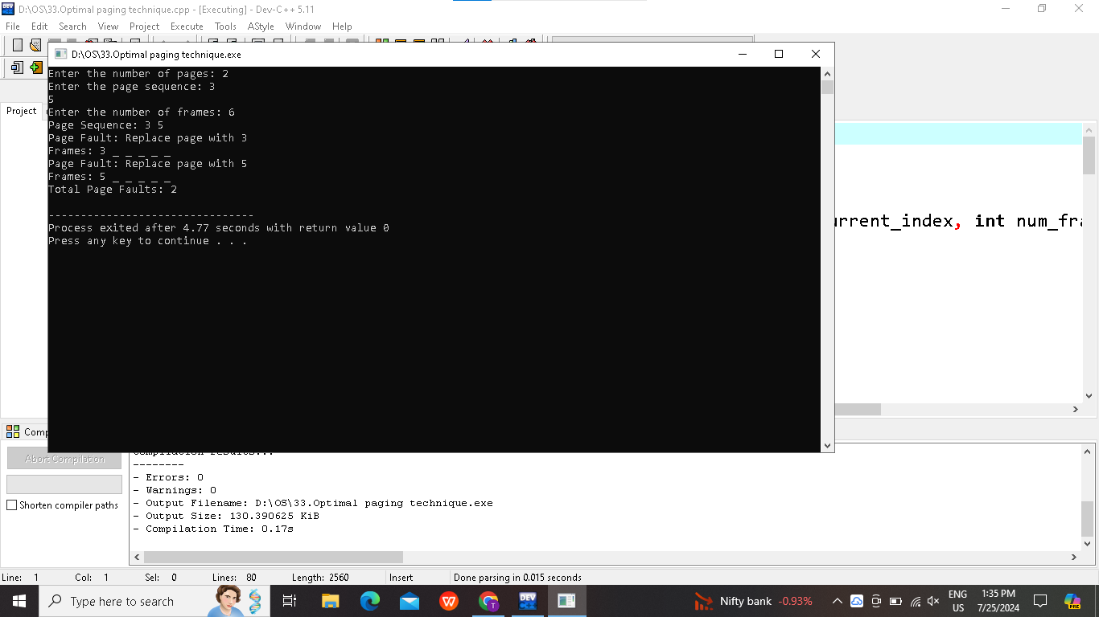
Result:
The code is successfully implemented using c program.
Experiment-34:
Aim:Consider a file system where the records of the file are stored one after another both physically and logically. A record of the file can only be accessed by reading all the previous records. Design a C program to simulate the file allocation strategy.
Program:
#include <stdio.h>
#include <stdlib.h>

#define MAX_RECORDS 100
#define RECORD_SIZE 50

typedef struct File {
char records[MAX_RECORDS][RECORD_SIZE];
int num_records;
} File;

typedef struct Directory {
File* file;
} Directory;

void create_file(Directory* dir, int num_records) {
if (num_records <= 0 || num_records > MAX_RECORDS) {
printf("Invalid number of records\n");
return;
}

File* new_file = (File*)malloc(sizeof(File));
if (new_file == NULL) {
printf("Memory allocation failed\n");
exit(1);
}

new_file->num_records = num_records;
for (int i = 0; i < num_records; i++) {
printf("Enter record %d: ", i + 1);
scanf(" %[^\n]", new_file->records[i]); // Read a line of input
}

dir->file = new_file;
}

void display_file(File* file) {
if (file == NULL || file->num_records == 0) {
printf("File does not exist or is empty\n");
return;
}

printf("File contents:\n");
for (int i = 0; i < file->num_records; i++) {
printf("Record %d: %s\n", i + 1, file->records[i]);
}
}

void delete_file(Directory* dir) {
if (dir->file == NULL) {
printf("No file to delete\n");
return;
}

free(dir->file);
dir->file = NULL;
printf("File deleted.\n");
}

int main() {
Directory dir;
dir.file = NULL;

int choice;
do {
printf("\nFile Allocation Simulation Menu:\n");
printf("1. Create File\n");
printf("2. Display File\n");
printf("3. Delete File\n");
printf("4. Exit\n");
printf("Enter your choice: ");
scanf("%d", &choice);
getchar();

switch (choice) {
case 1: {
int num_records;
printf("Enter the number of records: ");
scanf("%d", &num_records);
getchar(); // To consume the newline character left in buffer
create_file(&dir, num_records);
break;
}
case 2:
display_file(dir.file);
break;
case 3:
delete_file(&dir);
break;
case 4:
delete_file(&dir); // Clean up before exit
printf("Exiting...\n");
break;
default:
printf("Invalid choice. Please enter a number between 1 and 4.\n");
}
} while (choice != 4);
return 0;
}
Output:
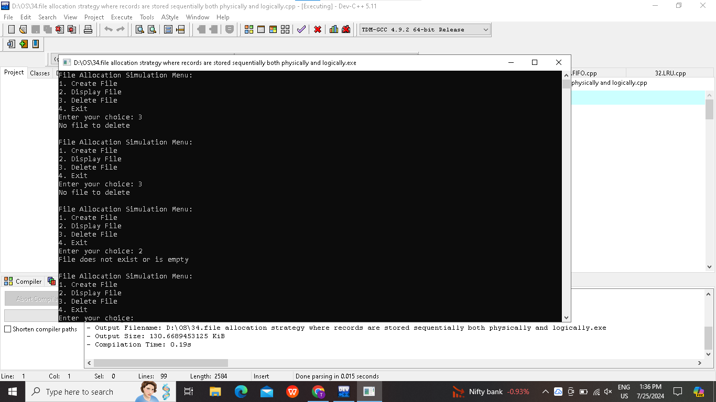
Result:
The code is successfully implemented using c program.

Experiment-35:
Aim:Consider a file system that brings all the file pointers together into an index block. The i^{th} entry in the index block points to the i^{th} block of the file. Design a C program to simulate the file allocation strategy.
Program:
#include <stdio.h>
#include <stdlib.h>
#define MAX_BLOCKS 100
#define BLOCK_SIZE 10
typedef struct Block {
int data[BLOCK_SIZE];
} Block;
typedef struct File {
Block* index_block[MAX_BLOCKS];
int num_blocks;
} File;
typedef struct Directory {
File* file;
} Directory;
Block* allocate_block(int* data, int size) {
Block* new_block = (Block*)malloc(sizeof(Block));
if (new_block == NULL) {
printf("Memory allocation failed\n");
exit(1);
}
for (int i = 0; i < BLOCK_SIZE && i < size; i++) {
new_block->data[i] = data[i];
}
return new_block;
}
void deallocate_blocks(File* file) {
for (int i = 0; i < file->num_blocks; i++) {
free(file->index_block[i]);
}
free(file);
}
void create_file(Directory* dir, int* data, int size) {
if (size <= 0) {
printf("Invalid file size\n");
return;
}
File* new_file = (File*)malloc(sizeof(File));
if (new_file == NULL) {
printf("Memory allocation failed\n");
exit(1);
}
new_file->num_blocks = (size + BLOCK_SIZE - 1) / BLOCK_SIZE;
for (int i = 0; i < new_file->num_blocks; i++) {
new_file->index_block[i] = allocate_block(&data[i * BLOCK_SIZE], size - i * BLOCK_SIZE);
}
dir->file = new_file;
}
void display_file(File* file) {
if (file == NULL || file->num_blocks == 0) {
printf("File does not exist\n");
return;
}
printf("File content:\n");
for (int i = 0; i < file->num_blocks; i++) {
for (int j = 0; j < BLOCK_SIZE; j++) {
printf("%d ", file->index_block[i]->data[j]);
}
printf("\n");
}
}
int main() {
Directory dir;
dir.file = NULL;
int choice;
do {
printf("\nFile Allocation Simulation Menu:\n");
printf("1. Create File\n");
printf("2. Display File\n");
printf("3. Delete File\n");
printf("4. Exit\n");
printf("Enter your choice: ");
scanf("%d", &choice);
switch (choice) {
case 1: {
int size;
printf("Enter the number of data elements: ");
scanf("%d", &size);
int data[size];
printf("Enter the data elements: ");
for (int i = 0; i < size; i++) {
scanf("%d", &data[i]);
}
create_file(&dir, data, size);
break;
}
case 2:
display_file(dir.file);
break;
case 3:
deallocate_blocks(dir.file);
dir.file = NULL;
printf("File deleted.\n");
break;
case 4:
deallocate_blocks(dir.file); // Clean up before exit
printf("Exiting...\n");
break;
default:
printf("Invalid choice. Please enter a number between 1 and 4.\n");
}
} while (choice != 4);
return 0;
}
Output:
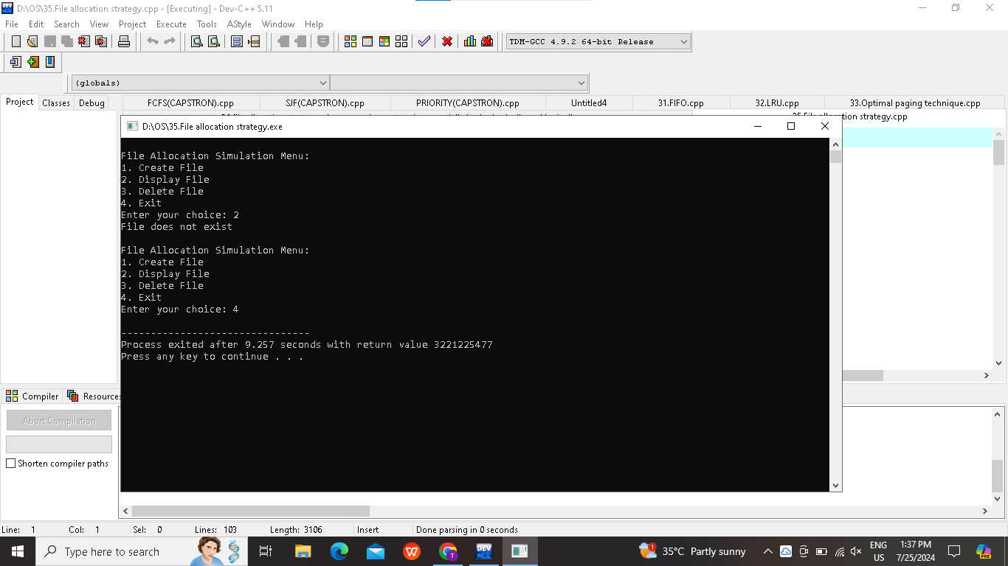
Result:
The code is successfully implemented using c program.
Experiment-36:
Aim:With linked allocation, each file is a linked list of disk blocks; the disk blocks may be scattered anywhere on the disk. The directory contains a pointer to the first and last blocks of the file. Each block contains a pointer to the next block. Design a C program to simulate the file allocation strategy.
Program:
#include <stdio.h>
#include <stdlib.h>
#define MAX_BLOCKS 100
typedef struct Block {
int data;
struct Block* next;
} Block;
typedef struct File {
Block* start;
Block* end;
} File;
typedef struct Directory {
File* file;
} Directory;
Block* allocate_block(int data) {
Block* new_block = (Block*)malloc(sizeof(Block));
if (new_block == NULL) {
printf("Memory allocation failed\n");
exit(1);
}
new_block->data = data;
new_block->next = NULL;
return new_block;
}

void deallocate_blocks(Block* start) {
Block* temp;
while (start != NULL) {
temp = start;
start = start->next;
free(temp);
}
}
void create_file(Directory* dir, int* data, int size) {
if (size <= 0) {
printf("Invalid file size\n");
return;
}
File* new_file = (File*)malloc(sizeof(File));
if (new_file == NULL) {
printf("Memory allocation failed\n");
exit(1);
}
new_file->start = allocate_block(data[0]);
Block* current = new_file->start;
for (int i = 1; i < size; i++) {
current->next = allocate_block(data[i]);
current = current->next;
}
new_file->end = current;
dir->file = new_file;
}
void display_file(File* file) {
if (file == NULL || file->start == NULL) {
printf("File does not exist\n");
return;
}
Block* current = file->start;
printf("File content: ");
while (current != NULL) {
printf("%d ", current->data);
current = current->next;
}
printf("\n");
}

void delete_file(Directory* dir) {
if (dir->file == NULL) {
printf("No file to delete\n");
return;
}
deallocate_blocks(dir->file->start);
free(dir->file);
dir->file = NULL;
}
int main() {
Directory dir;
dir.file = NULL;
int choice;
do {
printf("\nFile Allocation Simulation Menu:\n");
printf("1. Create File\n");
printf("2. Display File\n");
printf("3. Delete File\n");
printf("4. Exit\n");
printf("Enter your choice: ");
scanf("%d", &choice);
switch (choice) {
case 1: {
int size;
printf("Enter the number of blocks: ");
scanf("%d", &size);
int data[size];
printf("Enter the data for each block: ");
for (int i = 0; i < size; i++) {
scanf("%d", &data[i]);
}
create_file(&dir, data, size);
break;
}
case 2:
display_file(dir.file);
break;
case 3:
delete_file(&dir);
break;
case 4:
delete_file(&dir); // Clean up before exit
printf("Exiting...\n");
break;
default:
printf("Invalid choice. Please enter a number between 1 and 4.\n");
}
} while (choice != 4);
return 0;
}
Output:
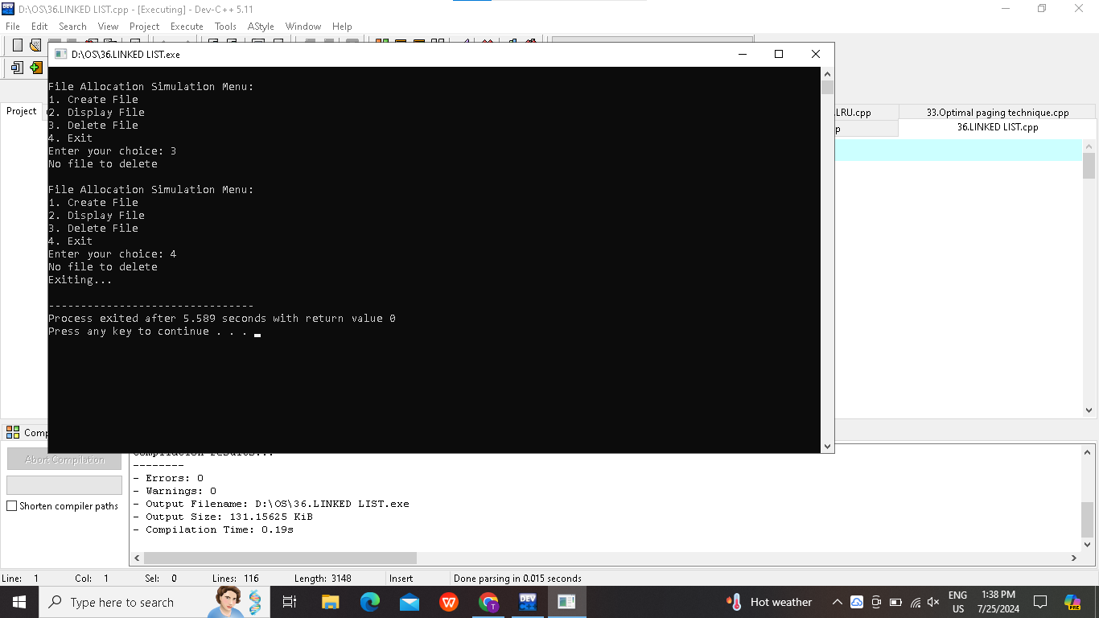
Result:
The code is successfully implemented using c program.

Experiment-37:
Aim:Construct a C program to simulate the First Come First Served disk scheduling algorithm.
Program:
#include <stdio.h>
#include <stdlib.h>
void fcfs(int requests[], int n, int head) {
int total_seek_time = 0;
int current_head = head;
printf("Seek Sequence: %d ", head);
for (int i = 0; i < n; i++) {
total_seek_time += abs(current_head - requests[i]);
current_head = requests[i];
printf("%d ", current_head);
}
printf("\nTotal Seek Time: %d\n", total_seek_time);
}
int main() {
int n, head;
printf("Enter the number of requests: ");
scanf("%d", &n);
int requests[n];
printf("Enter the requests: ");
for (int i = 0; i < n; i++) {
scanf("%d", &requests[i]);
}
printf("Enter the initial head position: ");
scanf("%d", &head);
fcfs(requests, n, head);
return 0;
}
Output:
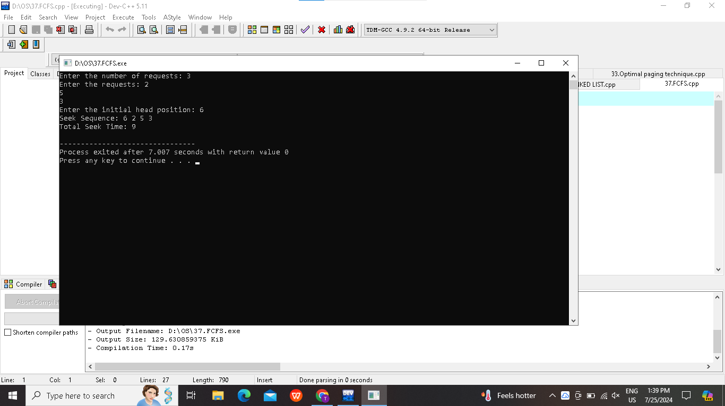
Result:
The code is successfully implemented using c program.
Experiment-38:
Aim:Design a C program to simulate SCAN disk scheduling algorithm.
Program:
#include <stdio.h>
#include <stdlib.h>
void sort(int arr[], int n) {
int i, j, temp;
for (i = 0; i < n-1; i++) {
for (j = i+1; j < n; j++) {
if (arr[i] > arr[j]) {
temp = arr[i];
arr[i] = arr[j];
arr[j] = temp;
}
}
}
}
void scan(int requests[], int n, int head, int disk_size, int direction) {
int i, seek_sequence[n+1], seek_count = 0;
int left[n], right[n], left_size = 0, right_size = 0;
if (direction == 0) {
left[left_size++] = 0;
} else {
right[right_size++] = disk_size - 1;
}

for (i = 0; i < n; i++) {
if (requests[i] < head)
left[left_size++] = requests[i];
else
right[right_size++] = requests[i];
}
sort(left, left_size);
sort(right, right_size);
if (direction == 0) {
for (i = left_size-1; i >= 0; i--) {
seek_sequence[seek_count++] = left[i];
}
for (i = 0; i < right_size; i++) {
seek_sequence[seek_count++] = right[i];
}
} else {
for (i = 0; i < right_size; i++) {
seek_sequence[seek_count++] = right[i];
}
for (i = left_size-1; i >= 0; i--) {
seek_sequence[seek_count++] = left[i];
}
}
int total_seek_time = 0;
int current_head = head;
for (i = 0; i < seek_count; i++) {
total_seek_time += abs(current_head - seek_sequence[i]);
current_head = seek_sequence[i];
}
printf("Seek Sequence: ");
for (i = 0; i < seek_count; i++) {
printf("%d ", seek_sequence[i]);
}
printf("\nTotal Seek Time: %d\n", total_seek_time);
}
int main() {
int n, i, disk_size, head, direction;
printf("Enter the number of requests: ");
scanf("%d", &n);
int requests[n];
printf("Enter the requests: ");
for (i = 0; i < n; i++) {
scanf("%d", &requests[i]);
}
printf("Enter the initial head position: ");
scanf("%d", &head);
printf("Enter the disk size: ");
scanf("%d", &disk_size);
printf("Enter the direction (0 for left, 1 for right): ");
scanf("%d", &direction);
scan(requests, n, head, disk_size, direction);
return 0;
}
Output:
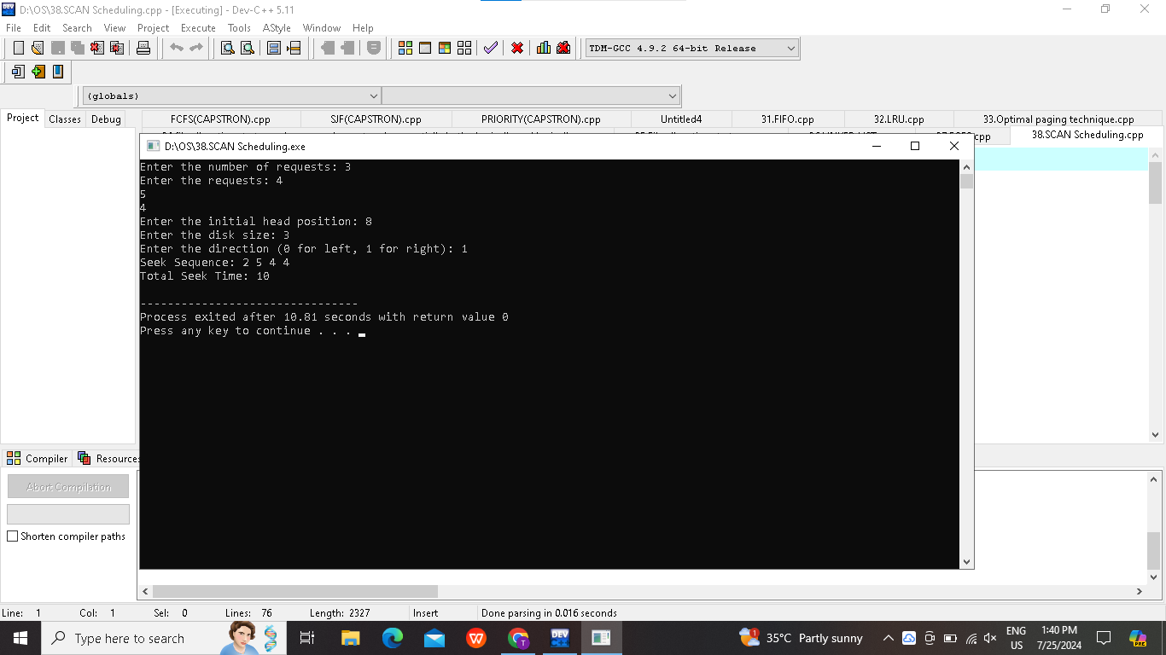
Result:
The code is successfully implemented using c program.
Experiment-39:
Aim:Develop a C program to simulate C-SCAN disk scheduling algorithm.
Program:
#include <stdio.h>
#include <stdlib.h>
void sort(int arr[], int n) {
int i, j, temp;
for (i = 0; i < n-1; i++) {
for (j = i+1; j < n; j++) {
if (arr[i] > arr[j]) {
temp = arr[i];
arr[i] = arr[j];
arr[j] = temp;
}
}
}
}
void cscan(int requests[], int n, int head, int disk_size) {
int i, seek_sequence[n+1], seek_count = 0;
int left[n], right[n], left_size = 0, right_size = 0;
for (i = 0; i < n; i++) {
if (requests[i] < head)
left[left_size++] = requests[i];
else
right[right_size++] = requests[i];
}
sort(left, left_size);
sort(right, right_size);
for (i = 0; i < right_size; i++) {
seek_sequence[seek_count++] = right[i];
}
seek_sequence[seek_count++] = disk_size - 1;
seek_sequence[seek_count++] = 0;
for (i = 0; i < left_size; i++) {
seek_sequence[seek_count++] = left[i];
}
int total_seek_time = 0;
int current_head = head;
for (i = 0; i < seek_count; i++) {
total_seek_time += abs(current_head - seek_sequence[i]);
current_head = seek_sequence[i];
}
printf("Seek Sequence: ");
for (i = 0; i < seek_count; i++) {
printf("%d ", seek_sequence[i]);
}
printf("\nTotal Seek Time: %d\n", total_seek_time);
}
int main() {
int n, i, disk_size, head;
printf("Enter the number of requests: ");
scanf("%d", &n);
int requests[n];
printf("Enter the requests: ");
for (i = 0; i < n; i++) {
scanf("%d", &requests[i]);
}
printf("Enter the initial head position: ");
scanf("%d", &head);
printf("Enter the disk size: ");
scanf("%d", &disk_size);
cscan(requests, n, head, disk_size);
return 0;
}
Output:
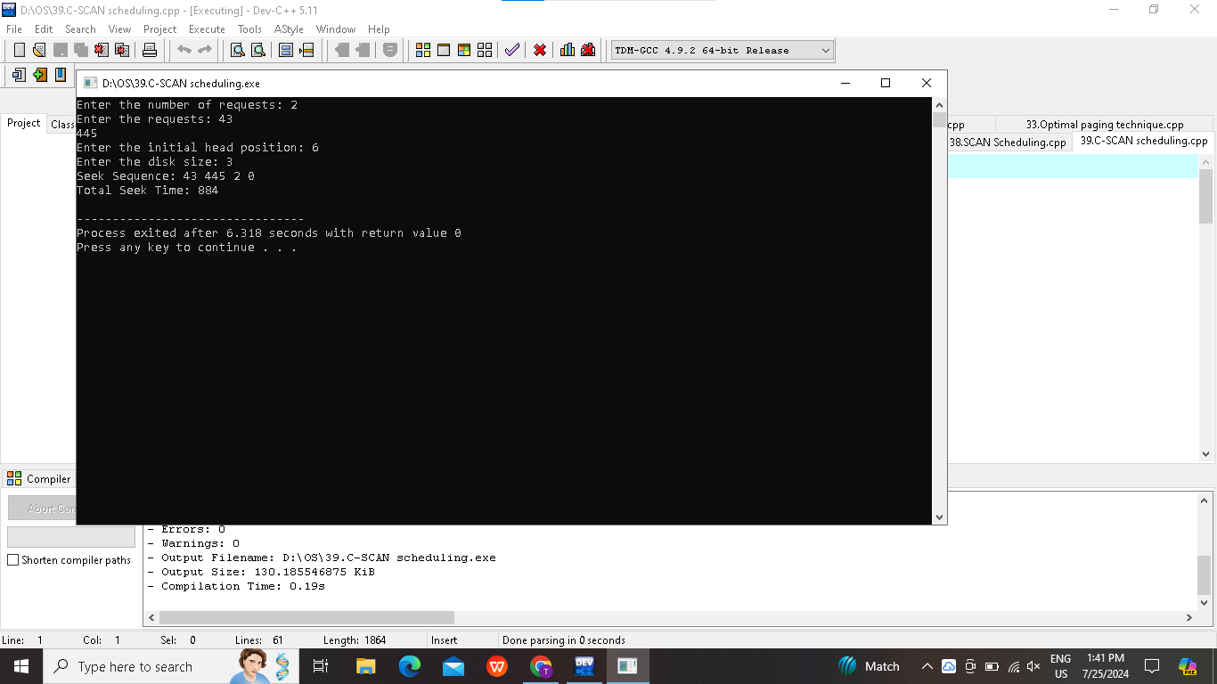
Result:
The code is successfully implemented using c program.
Experiment-40:
Aim:Illustrate the various File Access Permission and different types users in Linux.
Program:
#include <windows.h>
#include <tchar.h>
#include <stdio.h>
void PrintFilePermissions(LPCTSTR filePath) {
DWORD fileAttrs = GetFileAttributes(filePath);
if (fileAttrs == INVALID_FILE_ATTRIBUTES) {
_tprintf(_T("Could not get file attributes for %s (error %d)\n"), filePath, GetLastError());
return;
}
_tprintf(_T("File: %s\n"), filePath);
if (fileAttrs & FILE_ATTRIBUTE_DIRECTORY) {
_tprintf(_T("File Type: Directory\n"));
} else {
_tprintf(_T("File Type: Regular file\n"));
}
_tprintf(_T("Permissions: "));
_tprintf(_T((fileAttrs & FILE_ATTRIBUTE_READONLY) ? "r--" : "rw-"));
_tprintf(_T("r--"));
_tprintf(_T("\n"));
}
int _tmain(int argc, TCHAR *argv[]) {
if (argc != 2) {
_tprintf(_T("Usage: %s <file_path>\n"), argv[0]);
return 1;
}
PrintFilePermissions(argv[1]);
return 0;
}
Output:
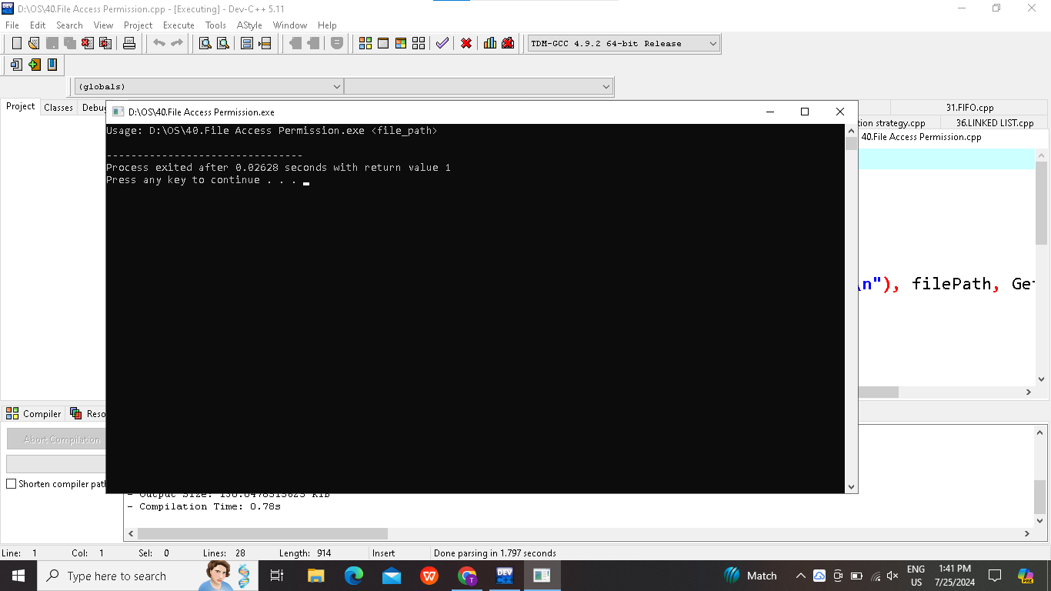
Result:
The code is successfully implemented using c program.

